An evaluation of Machine Learning as a Mental Health Support tool

Connor Murphy

BSc(hons) Computing, 2024

School of Design and Informatics
Abertay University

Table of Contents

Table of Contents i
Table of Figures ii
Table of Tables ii
Acknowledgements iv
Abstract v
Chapter 1 Introduction 1
1.1 Project Aims 2
1.2 Chapter Overview 2
Chapter 2 Literature Review 3
2.1 The use of Machine learning in mental health 3
2.2 Ethics of using Machine learning in mental health 3
2.3 ‌ Practical applications of Machine learn as Mental health Support tool. 4
2.4 What can affect keyboard Dynamics. 6
2.5 Eliciting Emotions from an Individual 7
2.6 Guageing User Experience with questionnaire 7
2.7 Summary 8
Chapter 3 Methodology 9
3.1 Development methodology 9
3.2 Version control 9
3.3 Python libraries used 9
3.3.1 Sklearn 9
3.3.2 Seaborn and Matplotlib 10
3.3.3 Pandas 10
3.3.4 Numpy 10
3.3.5 Joblib 10
3.3.6 PyQt6 10
3.3.7 Pynput 11
3.3.8 Miscellaneous 11
3.4 Data Preprocessing 11
3.5 MLA Development 12
3.6 Support Tool GUI Development 14
3.7 Support Tool Backend development 16
3.8 Testing 21
3.9 Testing results processing 22
Chapter 4 Results 24
4.1 MLA development testing results 24
4.2 SUS Survey Results 26
4.3 UEQ Survey results 31
Chapter 5 Discussion 33
5.1 MLA 33
5.2 SUS survey 34
5.3 UEQ survey 35
Chapter 6 Conclusion and Future Work 38
6.1 Future Improvements 38
List of References 39
Appendices 41

Table of Figures
Figure 3.1 Sklearn logo (Sklearn 2019) | 9
Figure 3.2 Main Window with two child windows (Python GUIs, 2021) | 11
Figure 3.3 CSV file of the raw training data gathered by Aicha Maalej | 11
Figure 3.4 Function to get accuracy and classification report for an MLA. | 13
Figure 3.5 Train test split and MLA initialization | 13
Figure 3.6 Design Page of the Qt creator App | 15
Figure 3.7 GUI of the Mental Health Support tool | 16
Figure 3.8 example code to initialise python app using an external GUI (Martin Fitzpatrick, 2021) | 17
Figure 3.9 The support tools initialisation of the GUI and the connection of the GUI buttons | 17
Figure 3.10 The class that holds all of the variables used by the support tool | 18
Figure 3.11 The code that the key logging feature uses | 19
Figure 3.12 The function that loads the test images | 20
Figure 3.13 The prediction function | 21
Figure 3.14 The function that calculate the data for a prediction | 21
Figure 3.15 Graph showing SUS score against percentile (Measuringu.com, 2024) | 22
Figure 3.16 Graph from the UQE data analysis tool | 23
Figure 4.1 Sus scores for each tester | 26
Figure 4.2 SUS survey Question 1 | 26
Figure 4.3 SUS survey Question 2 | 27
Figure 4.4 SUS survey Question 3 | 27
Figure 4.5 SUS survey Question 4 | 28
Figure 4.6 SUS survey Question 5 | 28
Figure 4.7 SUS survey Question 6 | 29
Figure 4.8 SUS survey Question 7 | 29
Figure 4.9 SUS survey Question 8 | 30
Figure 4.10 SUS survey Question 9 | 30
Figure 4.11 SUS survey Question 10 | 31
Figure 4.12 UEQ survey results breakdown | 31
Figure 4.13 UEQ survey mean of results | 32
Figure 4.14 UEQ survey results against benchmark | 33
Figure 4.15 UEQ survey results against benchmark as Graph | 32
Figure 5.1 UEQ survey results breakdown | 36
Figure 5.2 UEQ Survey inconsistencies | 37
Figure 5.3 UEQ Survey cleaned benchmark comparison | 38

Table of Tables
Table 1 results of testing different MLAs | 24
Table 2 results of testing different sets of training data | 24-25

Acknowledgements
I would like to acknowledge the project supervisor Dr Salma Elsayed as well as Oscar McCabe for the assistance, help and support provided during the development of this project.

Abstract
In the last decade, the prevalence of Mental Health diagnoses has exploded. This has naturally put a strain on Mental Health services resources to the point of near collapse. A potential solution to this problem is to utilize machine learning. There have been many studies conducted using machine learning to estimate a person’s mental state, potential mental conditions, and many potential tasks throughout the mental health treatment process. These studies used many different data sources for the machine learning algorithm including social media posts and digital biomarkers.

The goal of this project is to evaluate the plausibility of using machine learning within the field of mental health, specifically, as a tool to help people estimate their current emotional state and deal with it accordingly. To achieve this aim a multiclass classifier machine learning algorithm was developed to utilize a user's keyboard dynamics to estimate their current mood using Python. This was then built into a Python-based desktop application that uses a keylogger to take a user's keyboard interaction and feed it into the machine learning algorithm to then get a prediction. To properly evaluate this tool a user will use the tool and then fill out a usability and user experience survey. The results of which would show if the tool could be used by a person routinely, hence proving that machine learning could be used by mental health professionals.

The results of the survey showed that the tool was highly useable, and that the user experience was mostly above average. However, the machine learning algorithm was poor at predicting with an accuracy of 57%. This project concluded that despite the machine learning algorithm's poor performance, the survey's positive results showed that there is a want in the general public for this kind of tool. The tool could be improved by changing the machine-learning algorithm from a single multiclass classifier to multiple binary classifiers for each emotional state or alternatively, train the machine learning algorithm on highly personalized keyboard dynamics data for just one user.

Abbreviations, Symbols and Notation
ML Machine Learning
MLA Machine Learning Algorithm/s
SUS System Useability score
UE User Experience
UEQ User Experience Questionnaire
AI Artificial Intelligence
DP Deep Learning
NLP Natural Language Processing
CNN Convolutional Neural Network
SVM Support Vector Machine
ANN Artificial Neural Network
BPD Borderline Personality Disorder
KD Keyboard Dynamics
IAPS International Affective Picture System
ROC Receiver Operating Characteristic
EDA Exploratory Data Analysis
GUI Graphic User Interface

Chapter 1 Introduction

In the last five years, the number of people seeking mental health support has increased by upwards of 10% (BMA, n.d) and thats just in the UK. If that is extrapolated outwards to the rest of the world that is hundreds of millions of people. Here in the UK, the NHS is known for its lack of resources which includes the mental health sector, meaning a lack of trained mental health experts, psychiatrists, equipment, beds and aftercare. There is a clear gap between supply and demand, however, which has a huge impact on the lives of people who badly need these services. To combat this use of new technologies is paramount in the medical world. As such ML has been used in hospitals for years to help make diagnoses. In fact, one of the most famous ML data sets is used to detect heart defects using a patient’s medical data. So, what if ML can be similarly used throughout the Mental Health service process? If tools using ML could be made to help mental health professionals care for patients more easily, that could open them up to help more patients, helping to solve the supply issue.

ML works by feeding a computer data so it can find patterns. “Unsupervised” if we leave the computer to find the patterns themselves it usually finds connections humans could never have thought to make. There is also “Supervised” where alongside the data given there is a label, stating what the data results are. This way the ML can generally predict what group or result the data will lead to. MLAs do this by learning the data and forming connections between potentially thousands of data points. When the MLA is fed new data, it checks said data against all of these checks until the closest match is found. As such MLA can be 100% accurate so most MLA used in industries today have around 90 to 95% accuracy to allow for generalization. However, this process requires huge quantities of data with one line of data having upward of 5 values associated with them. Most MLAs need hundreds of lines of data to function efficiently. As such the collection of data is vital. There is also a need for the data to be relative, meaning the data is representative of the final result. If the MLA is trained on data that is not representative of the final result will still give the result that best fits the data provided. Not necessarily the true result of the data. Thankfully there has been much research in the field of using ML to estimate mental state. Finding many verified data sources that can be used by this Project to develop an MLA to estimate mental states. This project will use KD to make predictions as it was discerned to be the most feasible and non-intrusive way to predict a person's mental state. Due to ethical concerns about using ML to make diagnoses, this project only used ML to predict a person's mood and testing was only conducted by consenting adults.

1.1 Project Aims

The main goal this project aimed to achieve was to “Evaluate the potential of using a machine learning algorithm as a mental health support tool”. To effectively achieve this goal several objectives needed to be achieved:

- To obtain a suitable dataset with which to train the MLA.
- To review different machine learning algorithms for accuracy and suitability for purpose.
- To develop a trained and tune an MLA that predicts mood based on KD.
- To develop a desktop application that takes in user’s KD data and uses the trained machine learning algorithm to predict the user's current mood and give a positive supportive message.
- To organize supervised testing and surveys for testing on the application's usability and user experience.
- To analyse and evaluate the data from the surveys.
- To report findings and recommend further application development.

1.2 Chapter Overview

Chapter 2 looks at the existing literature that experimented with using ML in the mental health industry. As well as ethical concerns and other issues raised when conducting experiments to predict emotions.

Chapter 3 details the methodology taken in developing the support tool and the surveys used to evaluate said tool.

Chapter 4 of the dissertation displays the results of the surveys performed with testers of the support tool.

Chapter 5 focuses on a discussion of the results collected in Chapter 4 highlighting the reasoning behind the results and issues.

Chapter 6 states the conclusions drawn from this project.

Chapter 2 Literature Review
This chapter will review the methodology and importance of previous work and research carried out within the domain of ML in mental health. As MLA has many different aspects to consider, analysis of recent research will be used to provide evidence of the best ways of implementing a well-trained model. Moreover, a significant focus will be on how MLAs can be used to predict a person’s mood. As well as how they can be used in a legal and user-friendly manner.

2.1 The use of Machine learning in mental health
Over the last decade, AI and DP have found themselves in many industries and major parts of our everyday lives. The aspect this project is interested in is ML use in mental health. A recent article in the British Journal of Psychiatry written by Emma Rocheteau discusses this very topic. Broadly speaking the article found that there are 3 main areas in which ML is used “diagnosis tools, monitoring of symptoms, and delivering personalized treatment recommendations.” (Rocheteau, 2023). These three cover the whole process of treatment so there is a lot of potential for ML to be used. However, Rocheteau also highlights how ML’s known limitations could cause problems. These include MLA needing large amounts of numerical data to properly train on. As patients’ raw medical data are scaled by law this project will have to find a different kind of data to use. This will be discussed later. Another limitation is that by their nature MLAs are highly specified to perform a single specific task. Meaning that many ML models will have to be trained to do different tasks which is not cost-effective to make or run. Lastly, the biggest limitation, no MLA is correct all the time meaning there is a non-zero chance of misdiagnoses and mistakes. In a medical scenario, this could be catastrophic leading to incorrect treatment and at worse death. This opens the topic to ethical issues. Ethical issues that this project will need to identify and address.

2.2 Ethics of using Machine learning in mental health

These ethical concerns are either similar or identical to the concerns that occur when using ML as previously mentioned. To fully understand these concerns and issues, this project found an article written by Jessica Morley and others. They scoured 5 literature databases and found that the most reoccurring concern was, as previously stated, misdiagnosis and its possible repercussions. As Morley put it there are two possible causes for this. Firstly, the input device is not properly functioning or the MLA itself is misdiagnosing. (Morley 2020). The other concern is the individual patient’s data and their rights as to how it is used. Morley asserts that “the increasing use of algorithmic decision-making in clinical settings can have negative implications for individual autonomy,” (Morley 2020). Specifically, Morley says that in order to have autonomy over their own AI-driven treatments they would need to understand what data is being used and how the MLA is using said data to reach a decision. As ML is a specialized subject in its own right it is highly unlikely the patient will be able to fully understand the subject in a timely manner. That is on top of the issue of the patient not trusting a “machine” to give them medical treatment in the first place. Given these ethical concerns, this project will concentrate it’s efforts on designing an application that does not diagnose the user. One thing that this project has made note of is that this paper was published in 2020 meaning that with the ever-changing nature of ML, these concerns may be outdated with new laws, and new unknown issues could have arisen.

2.3 ‌ Practical applications of Machine learn as Mental health Support tool.
As previously discussed, ML has the potential to be used at any point during mental health treatment. As such there have been many papers and articles that have experimented with different methods of implementation.
One such example is an article written by Jina Kim and others where they used social media posts to accurately identify if a poster shows a given mental illness. This was done using NLP using a CNN to make six binary classifiers. These classifiers determined if the poster shows depression, Anxiety, bipolar, BPD, schizophrenia, and autism or not. The text for the training of these models was taken from Reddit threads discussing mental disorders. The posts were prepared using standard NLP procedures. Kim found that the classifiers had high accuracy with accuracy ranging from 70 to 90 percent. With the highest being autism 96.96% (Kim 2020). This method is a great example of helping diagnose or monitoring a patient but the main flaw this project sees is that despite living in today's age some people choose not to use social media. To make full use of this method a patient would have to make continuous posts potentially multiple times per day. This is not always feasible as people suffering from these illnesses are not likely to reach out socially. Also, people tend to unconsciously alter the way they act when interacting with people and this could mask the true result from the classifier. In order to make a support tool that functions well it needs to not be invasive or require the user to consciously think about it. As such the project needs another method.
A different method is to use would be digital biomarkers. These biomarkers include measurements such as heart rate, levels of physical activity and sleep patterns. However, through many recorded experiments, it has been found that these biomarker patterns are disrupted by mental states both positive and negative. Biomarkers can be easily measured using wearable devices such as Fitbit. Yuri Rykov and others created an experiment to data collect by a Fitbit Charge 2 worn by 290 participants over 14+ days. Rykov hoped to use the data generated by this method and diagnoses from self-report questionnaires, to prove that ML taught on this data could be used to predict depression. Rykov found that relatively few digital biomarkers correlated with high-level depression. The most significant of witch is “greater variation of nighttime heart rate between 4 AM and 6 AM” (Rykov 2021). The greater the variation the greater the possibility. However, the MLA only showed promise when the model was doing a binary classification between people with no depression and those with high levels of depression. This and a few other points make this method of prediction unsuitable for this project. One of the major limitations of this method is as Rykov identified the fact that, the pool of participants did not include any clinically diagnosed participants with depression, All the levels of depression gained from the questionnaire being self-diagnosed. While this is an excellent way of monitoring a patient it doesn’t allow for active support. so Due to this and the dubious nature of possibly skewed data as well as the timeline needed to collect the data being longer than this project allows, this project deems this approach nonviable.
The approach that this project opted for was based on a paper by Aicha Maalej. The paper describes a method of collecting and using KD to estimate the user’s current mood. KD is much like handwriting, except it deals with typing instead of writing. The kind of things KD measures include the timings between button presses and the number of times backspace was pressed. As described previously mental states can affect the body in many ways. Maalej focused on muscle fluctuations, believing that these fluctuations could affect typing. In their words “ i.e. the rhythm, with which human fingers are used to type on a keyboard, can be different for different emotional states” (Maalej 2020). Now this is not a recent idea, a lot of research has been done in the field of KD being used to recognise emotion. Showing promising results and as a result, it has become a commonly utilized method. After doing his own systematic review Maalej developed a method of collecting the data needed to train an MLA. He designed a web application that induced an emotional state by showing a video. Before and after the participant was prompted to type in a fixed or free piece of text. Before being a supposedly neutral state. To ensure the participant was concentrated on the video and task. The web application asked the participant a question on the video. The correct answer showing the participant watched the video and is in the expected emotional state. From this data, features were extracted mainly focusing on the timings between button presses. Maalej experimented with many MLAs with great success, with accuracy ranging from low 90s to mid 60 in percentages. With SVM and ANN being the top scorers with 90+%. This method of using KD to estimate emotional state is perfect for this project as it is easily implemented into a desktop or web application. This is compounded by the dataset Maalej developed being free to use for research, meaning the project can start with a data set ready to use. For these reasons, this project will use the method laid out in this paper. However, some issues should be kept in mind. First, as Maalej puts it “we should note that most of them used small datasets with a low number of users” (Maalej 2020). Them being other papers using KD to generate their data, this and the fact that the way people type is very different just like handwriting. This means that training a model generalized for public use may be unfeasible or realistic.

2.4 What can affect keyboard Dynamics.

With the previously mentioned issues in mind, this project has researched what can affect KD and found an article that investigated this subject. Although the paper studied specifically keyboards on mobile phones this project sees it as comparable to using a mechanical keyboard. Claudia Vesel compared over 85000 typing sessions from 543 participants from all backgrounds. Vesel found that there was a significant non-linear diurnal pattern for typing speed and variability. Specifically, the least variable typing was between midday and 1500, proving that even the time of day can affect typing. Vessel also found that younger people tended to write up to 60% faster and with greater accuracy then older generations. With this in mind, it would suggest that for this project to succeed the MLA will need to be tailored to the individual or tailored to a specific demographic. This should not be a problem for this project as the dataset mentioned earlier was generated by university students. With the testing of the support tool acted out by university students.

2.5 Eliciting Emotions from an Individual

To properly test the emotional estimation of the support tool it will be necessary to induce the desired mood from the tester. This exact topic has been heavily tested in the field of psychology for many years now. An experiment in 2018 by Ewa Siedlecka tried to find the best method to induce a given emotion. According to Siedlecka “the most effective induction method for the six basic emotions is visual stimuli.” (Siedlecka, 2018) the basic emotions are anger, disgust, surprise, happiness, fear, and sadness. All but disgust are present in Maalej’s data set. A problem arises when choosing an image or video to show the tester as different people perceive things differently. To combat this this project will use the IAPS image archive. IAPS is a set of images widely used and validated by hundreds of papers, that induce the basic emotions in people. With each picture annotated IAPS guarantees that many people will feel the same way about said picture.

2.6 Guageing User Experience with questionnaire
To properly answer the main research question of this paper, the support tool will need to be properly tested for usability and user experience. Despite the support tool being little more than a proof of concept, it nevertheless needs to be tested, to discover if ML can be used in real-world Mental Health scenarios. For testing the usability of the support tool, the SUS survey has been used as an industry standard for decades. It's easy to administer and is thoroughly validated to determine the usability of a given system. Gauging UX can be very challenging and writing questions from scratch can lead to important information being lost. As such this project has deemed the use of a predesigned set of questions to be appropriate. A paper by Ignacio Díaz-Oreiro and others was found. In this paper, a literature review was conducted searching for the use of three UX questionnaires (AttackDiff, UEQ, and meCUE). The first two work off of the Hassanal model and the last uses the Thüring and Mahlke model. From over 946 papers it was found that AttackDiff has seen the most uses. However, Diaz-Oreiro found that “UEQ is growing at a faster pace, surpassing AttrakDiff in 2017 and 2018 by 42% and 47% of uses, respectively.” ( Diaz-Oreiro 2021) this trend shows that UEQ is beginning to be seen as being more accurate and trustworthy. The project sees fit to follow this trend and use the UQE to evaluate UX.

2.7 Summary
Given the ethical issues found by this Literature review, this project will instead of designing an MLA that diagnoses a person with a given illness, will instead design a MLA support tool that predicts the user's current mood. It will then advise on how to deal with that emotion if negative, while reinforcing positive emotions as well. The MLA will be trained on KD data provided by Aicha Maalej and during testing the participants will be shown curated images from the IAPS to induce the desired emotion. Then to properly gauge the UX a UEQ will be used.

Chapter 3 Methodology
This chapter will discuss the processes and technologies used to develop the mental health support tool and how usability and user experience were measured. As Python provides the best libraries and tools for developing MLA this project decided to develop the whole support tool in Python. To avoid tangents during the methodology breakdown, the libraries and their functions used will be described first alongside the high-level development details.

3.1 Development methodology

Due to the essence of this project, an Agile Incremental Development approach was chosen. This is because despite the support tool being a proof of concept there is still a need for each successive version of the tool usable and built upon older versions. This ensures that changes can be made effectively if the need arises. This ability to make changes throughout this project is vital as the developer has had little experience with some of the libraries and tools deployed within this project, so mistakes and improvements are likely to be made. To ensure the project proceeds smoothly a Gantt chart has been created to provide an overview of tasks that need prioritizing over the time frame of the project. And to provide structure to the development of the project (see Appendix A).

3.2 Version control

GitHub was used as the provider of version control for this project. GitHub offers an interface that provides access control for managing versions of a project. GitHub being a distributed version control system can track changes in source code added to files during development. The use of proper version control is vital within this project as it allows for rollback with ease. It will also act as the main repository for the project in case of corruption or loss of data. GitHub also fits perfectly within an incremental development methodology due to its ability to allow changes to be made and pushed cleanly and efficiently.

3.3 Python libraries used

3.3.1 Sklearn

Figure 3.1 Sklearn logo (Sklearn 2019)
Sklearn is one of the most commonly used ML libraries as it contains over 200 different MLAs for Classification, Clustering, Dimensionality Reduction and Regression. This library was chosen due to its use in industry and this projects developer understands the library well.

3.3.2 Seaborn and Matplotlib

The Seaborn and Matplotlib are both libraries that produce graphic visualizations of data using different graphs. For this project they were primarily used to generate the results from MLA. Seaborn was used to create confusion matrixes showing true and false positives on the predictions of the MLA. Whereas Matplotlib was used to plot ROC curves and precision-recall curves. Examples of these graphs can be seen in Appendix C.

3.3.3 Pandas

The Pandas library focuses on manipulating and analysing massive data sets or big data. It was used in this project to perform EDA and data pre-processing.

3.3.4 Numpy

The numpy library adds functions that allow for the use of large multi-dimensional arrays that hold multiple data types. It was primarily used in this Project to mould the data used in individual test cases. To also hold the data sent to the MLA in the support tool.

3.3.5 Joblib

Joblib provides functions to make lightweight pipelining possible in Python. Joblib was vital in this project as it provided a method for the support tool to use the MLA.

3.3.6 PyQt6

PyQt6 was one of the two most important libraries used in this Project. As PYQt6 provides canvases and components to build a GUI. A fundamental component for Desktop Applications. The reasoning for the use for this particular library will be discussed in section 3.5.
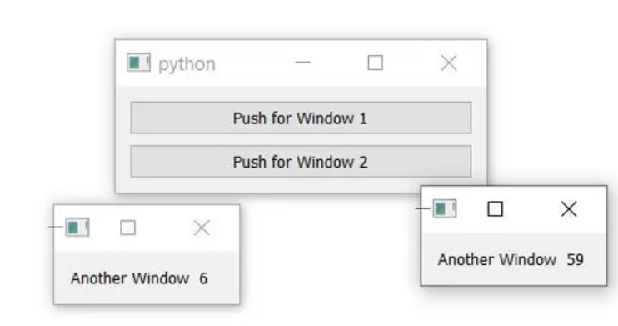
Figure 3.2 Main Window with two child windows (Python GUIs, 2021)

3.3.7 Pynput
The other most important library Pynput offers functions to handle inputs from input devices, such as a mouse or more importantly to this Project a keyboard. By creating a new thread with a listener real-time keyboard data can be collected. With this KD can be collected then sent to the MLA for a prediction.

3.3.8 Miscellaneous

There are a handful of libraries used in this Project that are worth mentioning Time, Threading and random. Time was used to find the exact time a button was pressed. Threading was used for the mutex functions to avoid race conditions caused by the pynput listener. Finally random is used to select the encouraging message displayed to the user.

3.4 Data Preprocessing

With the dataset precompiled by Aicha Maalej, the project could start with EDA. The data set used was data from participants writing a fixed set of text and was taken from 125 total participants. All of whom were university students so well educated 20–30-year-olds. The data set itself consists of 14 columns with 46872 rows. The 14 columns can be seen below. 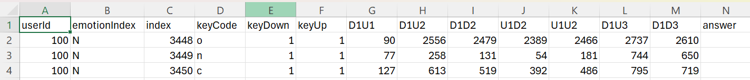
Figure 3.3 CSV file of the raw training data gathered by Aicha Maalej

- UserId is just the Id of the user that generated the row of data.
- emmotionindex is the mood state the user was in during data collection.
- Index is just the primary key of the rows.
- KeyCode is the last key pressed when the data was submitted.
- keyDown is the exact timestamp of the key-down event.
- keyUp is the exact timestamp of the key-up event.
- D1U1 is the time between first key down and first key up 1.
- D1U2 is the time between first key down and second key up 2.
- D1D2 is the time between first key down and second key down 2.
- U1D2 is the time between first key up and second key down 2.
- U1U2 is the time first key up and second key up 2.
- D1U3 is the time between first key down and third key up 3.
- D1D3 is the time between first key down and third key down 3.
- Answer acts as a built-in filter for ensuring that the data is accurate.
During the development of the MLA, the training data was processed in many ways but that will be discussed in the following section. The final version of data preprocessing had the rows with null values removed. It was then found that the data being read into the pandas dataframe was not maintaining its data type. To solve this the columns were explicitly cast to the correct data type. Some EDA was done and it was found the UserId and index were unneeded, as User ID specifies the data to a specific user. Index is just a unique identifier for each row. emmotionindex was then identified as the target variable and was converted from letters to numbers. N neutral being 0, C calm being 1, H happy being 2, A angry being 3, and S sad being 4. This was done to one hot encode the value but as a single digit. This was accomplished using the find and replace tool in Excel to save time by developing code to do the task. A similar method was used with keycode but here the letters were changed to their ASCII values. This way in the tool itself letters won’t have to be mapped to values and can be easily transformed. Lastly, the filter Answer uses was implemented. During data Collection Maalej ensured users were focused on the task by asking a question about the video used to elicit the emotion. A correct answer assumed that the user was engaged and in the correct emotional state. So, any rows labelled with a “W” for wrong were removed and then the answer collum was removed as it was no longer needed.

3.5 MLA Development

The main problem this Project needed the MLA to solve is to use labelled data to learn to estimate a user’s mood from a preset list. That means that the MLA needs to be a supervised multi-classifier. So the initial stages of development were to find the most accurate MLA for the data and refine from there. Of note is that to properly test a Multiclass classifier MLA, the one vs many classifier from Sklearn was used. It was used to test classifying predictions of one class against all other classes for each class. So, to test the MLAs, each test used MLA code including a function seen in Figure 3.4 to measure the accuracy of the model, a classification report for it as well, and a confusion matrix for predictions.

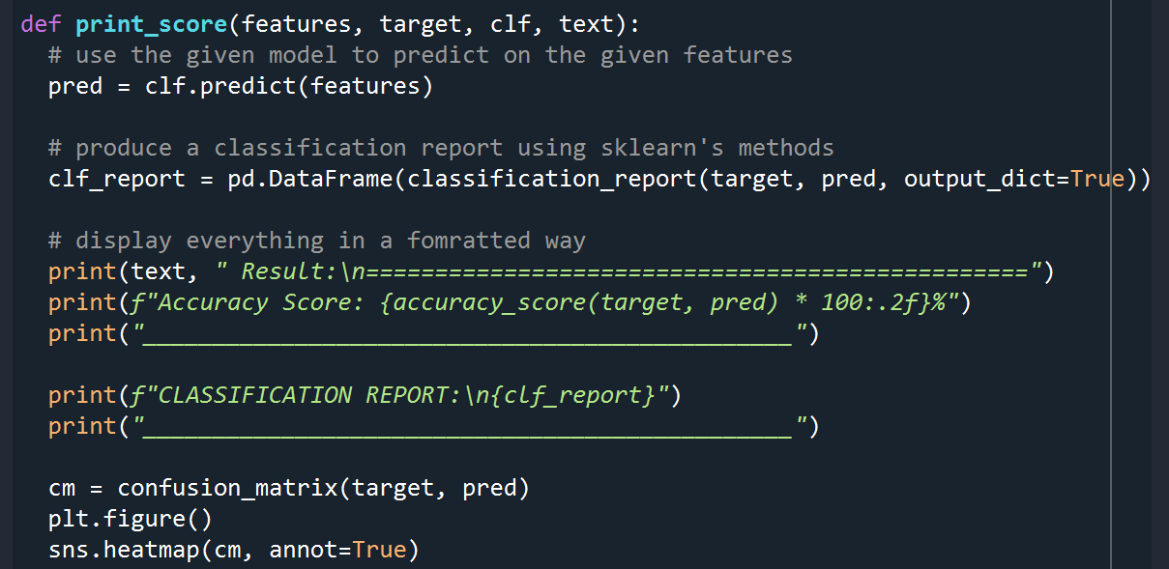
Figure 3.4 Function to get accuracy and classification report for an MLA.

On top of that two more graphs were coded to show the ROC curve for each class and a Precision-Recall for the model’s predictions. Then 5 individual test cases for each class to see how the model reacts to unforeseen data. Following Maalej’s paper, the 5 MLAs tested were Random Forest, K-Nearest Neighbour, Multi-layer Perceptron, and Native Bayes all without hyper tuning. At this stage, the data was split with the standard 80-20 and processed to remove UserID, index, Keycode, and answer which at the time was deemed unnecessary. Quickly however a problem was found. None of the MLAs had an accuracy over 33%. After repeating the test three times for each MLA, it was confirmed. The Summarized results of these tests can be found in Chapter 4 and the raw results are in appendix C. Due to there being no clear best MLA the Project used the MLA the developer is most familiar with Random Forest. Another reason was that the confusion matrixes for predictions on the training data showed around 99.9% accuracy. This was a clear sign of overfitting, but it was clear that the MLA was able to learn from the data. With this in mind, the Random Forest MLA was hyper-tuned as shown in Figure 3.5.

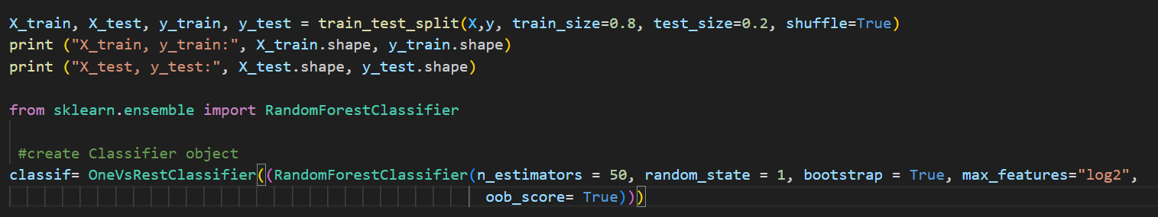
Figure 3.5 Train test split and MLA initialization

As can be seen, the number of estimators was set to 50 half the default of 100. This was done to avoid the overfitting seen in the initial set of tests. random_state was set to 1 to get consistent results across development and tests. Bootstrap was set to true to ensure that the MLA uses its bootstrapping method to the fullest. Max features use log2 to take as many features as possible to ensure the MLA learns the data. Lastly, oob_score was set to true to be able to validate the accuracy value calculated in the function seen in Figure 3.4.

Again, further problems arose while improvements were made the accuracy only rose to around 39%. Despite changing the hyperparameters to many different combinations the accuracy always only changed by 1-2% both ways. From this, it was theorized that the training data was flawed. so many different alterations were done. It was discovered that class zero neutral had up to 3x more rows than any other class, so tests were done by collapsing the data down to 3000 rows per class, removing the neutral class, and collapsing the 5 classes into 3 classes, by combining the two positive states into one and doing the same with the negative states. The only marked improvement seen was the collapsing of 5 classes into 3 with 59% accuracy. At this point, the Data Pre-processing code was re-examined and the keycode column was reintroduced to add more features to the dataset. This worked with the accuracy of the model increasing to 57%. However, the MLA was still heavily prioritizing class 0 over any other class, so the same training data alteration tests were repeated however, no change resulted in an accuracy of over 60%. Also, every test that included class 0 neutral was heavily preferred by the MLA. Due to timeframe constraints no more MLA development took place during the Project. The MLA with the best results used the data set with keycode added with the hyperparameters seen in Figure 3.5 were used. The trained MLA was then saved to an external file using Joblib for use in the support tool.
The full code for the MLA can be found in Appendix G.

3.6 Support Tool GUI Development

To streamline the development of the GUI QT Creator was used. OT Creator is a cross-platform, integrated development environment for developing apps on multiple operating systems. This Project used these tools to develop a UI for the support tool to use.

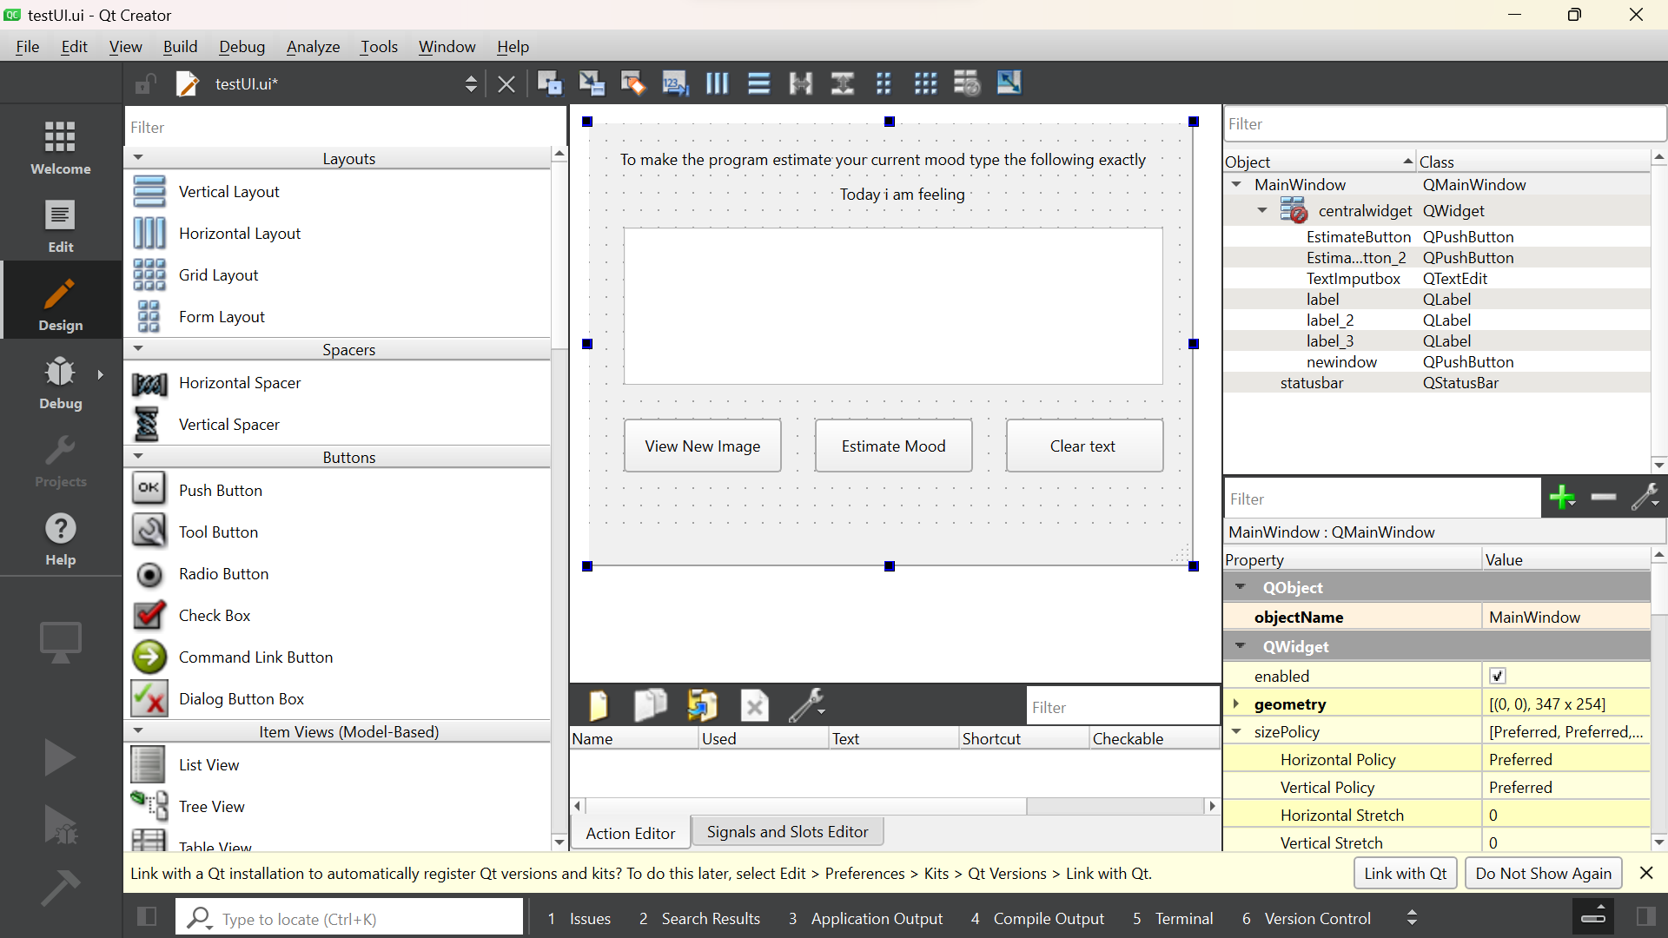
Figure 3.6 Design Page of the Qt creator App

As shown in Figure 3.3 it is a drag-and-drop system so changes can be made quickly. Of note however, is the need to use a Python command in the command line to transform the generated .ui file into a Python file that can be called from the main file to initialize the GUI. This is due to QT creator being for use across platforms for the file needs to be transformed before use in this case in a Python Program. The use of the Python UI is further streamlined as the creators of QT Creator also developed the PyQt6 library. So, the UI file is called using a built-in UI reader function and it is ready to use. For this Project said UI needed to be neutral and as simple to use as possible. This was to ensure that the UI did not influence the user's emotional state giving a clear uninfluenced reading from the support tool. To this end, the colour scheme was kept to greys and whites. The buttons were kept to a minimum amount and were ladled with clear instructions. As Appendix B shows the layout when a few a handful of iterations. The final layout (1) was chosen because the intended users of the support tool are English readers. Meaning that they read left to right. So, to streamline the process the three buttons were ordered show image, estimate mood, and clear text. All of this gave the final UI shown below.
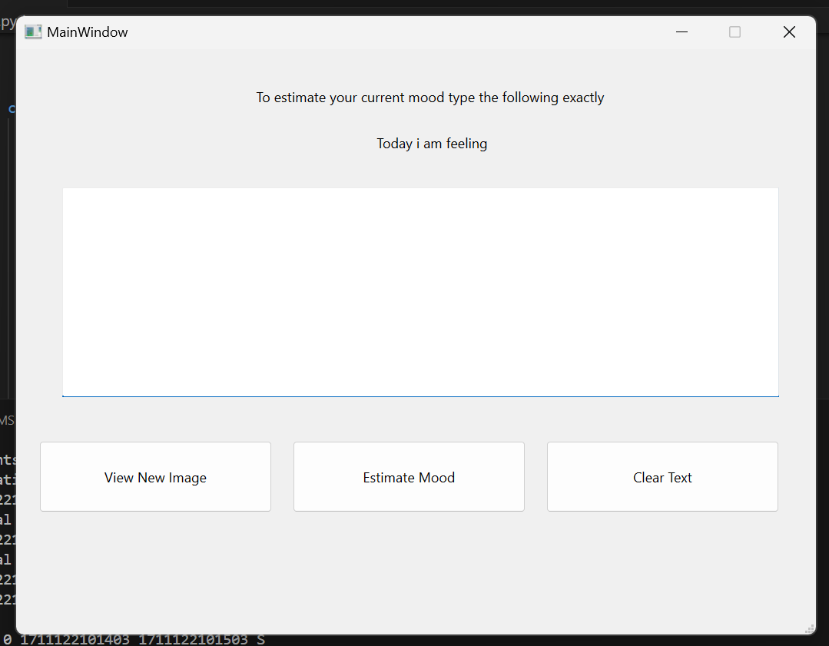
Figure 3.7 GUI of the Mental Health Support tool.

3.7 Support Tool Backend development

With the Front-end development finished it was time for back-end development to begin. The first step was to load in the UI and connect all of the buttons. As previously mentioned PyQT includes a function that loads in an external UI called “setupUI”. As shown in Figure 3.8 below the UI is imported as a Python class which is then used during the initialisation of the main GUI window. Then the program is cast as a desktop application. The main GUI is readied and then shown and finally, the application is executed presenting the user with the GUI.
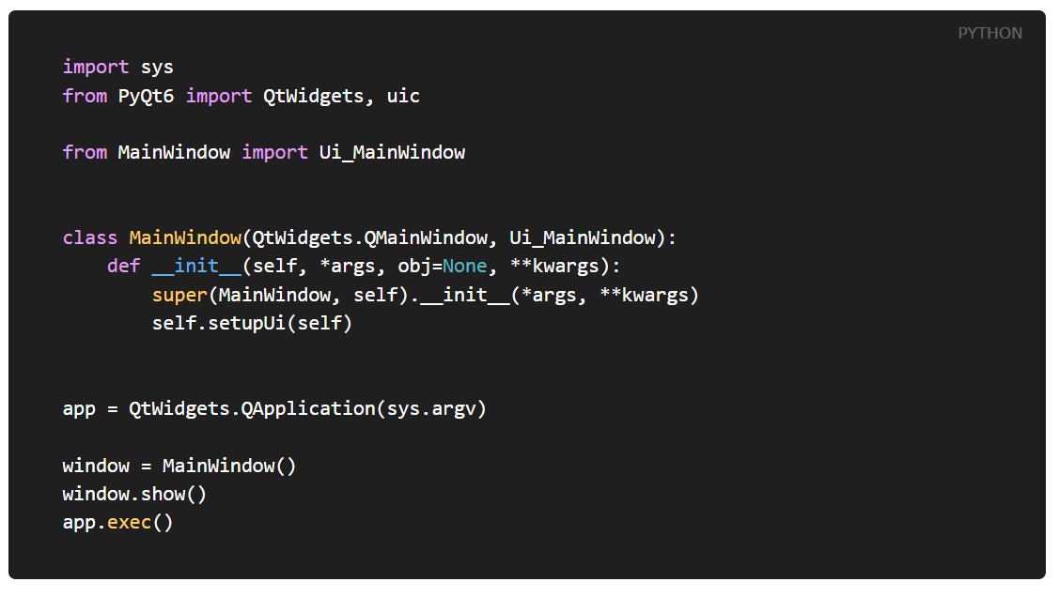
Figure 3.8 example code to initialise python app using an external GUI (Martin Fitzpatrick, 2021)

The version the support tool uses is seen below in Figure 3.9. Is largely similar but the UI class is explicitly called and the functionality of three buttons is set up, so their related functions run when the button is clicked.

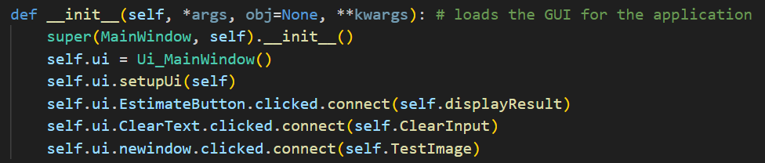
Figure 3.9 The support tools initialisation of the GUI and the connection of the GUI buttons.

The support tool needs access variables at multiple points in the code at different times. It was clear that a form of global variables would need to be used to hold the data in between uses. Following Python programming best practices, a new class was made to hold all of the variables as can be seen in Figure 3.10. Consulting the figure the first variable showimg is used to show the various testing images. kd1 to ku3 hold the KD of the last three button presses. kutemp and kdtemp are placeholders for holding the variables when updating kd1 through ku3. Keycode to D1D3 holds the data that the model will predict with. Check is used to validate key presses.
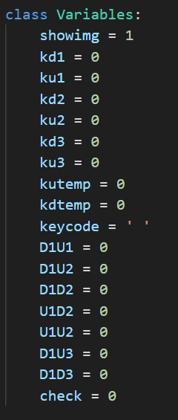
Figure 3.10 The class that holds all of the variables used by the support tool.

The functions that use kd1 to ku3 can be seen below in Figure 3.11. Figure 3.11 shows the pynput functions that record the user's keyboard interactions and the listener that runs them. As discussed previously the listener runs on a new thread. As such the listener is initialized just before the GUI is initialized. As for the functions themselves, there is one for when a key is pressed and one for when it is released. The on_press function gets the current time in milliseconds and what key was just pressed. However, since the training data is based on the English alphabet and punctuation, a special key like shift will cause errors so fix this issue a try catch exception was implemented. While normal letter key presses are recorded, control key presses nothing is recorded and the check variable is changed to 1. The on_relese function also records the current time in milliseconds when a key is released but it also takes the two temp variables that hold the most current keyboard interactions and sends them to a function to update kd1 through kd3. As seen on-relese only runs when check is not 1. So when a special key is pressed the update function is not run and check is reset hence stopping the potential error. The update function moves the variables along with kd3 becoming kd2 and ku3 becoming ku2 and so on. Essentially keeping the times of the press and release paired up with the most recent key interaction being kd3 and ku3. With sets 2 and 1 working sequentially backward through time. There is a problem with this function however. As it is run on a separate thread and the function assesses variables that are used elsewhere on the main thread this can cause a race condition. To combat this the function call is warped in a mutex lock so no other threads can access the variables while they are being updated.

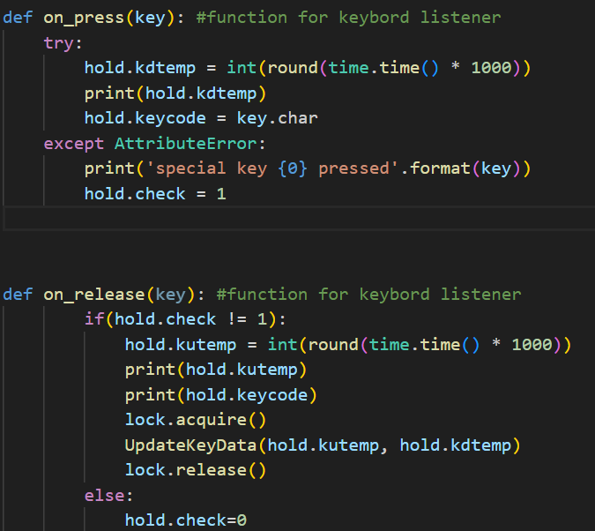
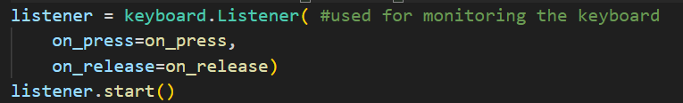
Figure 3.11 The code that the key logging feature uses.

This brings us to the functions used by the buttons. The simplest is the function tied to the clear text button. It's a simple one-line command that removes any text currently in the text box. This was done to streamline testing as well as act as a mood cleanser. A simple action that acts to bring the participant back to a neutral state before being exposed to the next inducing image.

The function that shows said image is slightly more complex as seen below. It is just opening a new dialog box containing an image when boiled down. This is where the showimg is used. In essence, it's used to show the different test images by representing the image's file name. The images themselves are stored in the same folder as the tools python file and are named in order from 1 to 5. Each time the view new image button is pressed showimg is incremented. So, the new time the button is pressed the new image in order is shown, and once the last image is shown showimg is reset to one to restart the process.

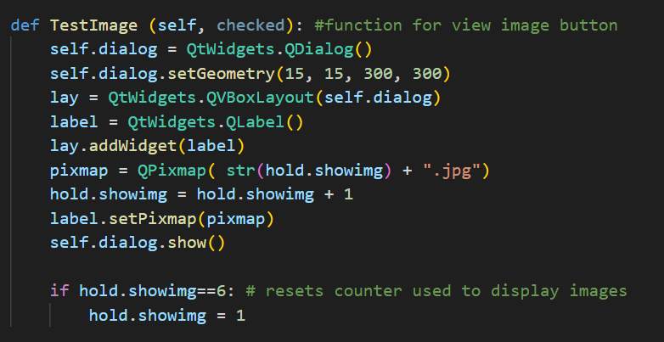
Figure 3.12 The function that loads the test images.

The final button function seen in Figure 3.13 is the one that makes the prediction and displays the result. First, the CalculateInput function is called to calculate the inputs. The function can be seen in Figure 3.14 and essentially it just finds the difference between the different presses and releases by subtraction. Then ascii value of keycode is found using the ord method. Next, all the inputs are entered into a numpy array to be sent to the model or prediction. First, the numpy is reshaped into (1, -1) so the model knows it is a prediction on a single row of inputs. Once the prediction is made the prediction variable is transformed into a string to get the prediction digit which is transformed back into an integer. That integer is then used in an if else statement to get the right emotional state to put into a new string. That string is then displayed in a new dialog box with a corresponding supporting message. The supportive messages are stored as a Python dictionary with the class predictions acting as the key. The value side holds a list of 3 strings. These strings are messages corresponding to each class. Reassuring quotes for sad predictions, breathing exercises for angry, and positive reinforcement for happy and calm predictions. The supportive message is selected using the prediction variable and a random variable between 1 and 3.
The full code of the support tool can be found in Appendix H

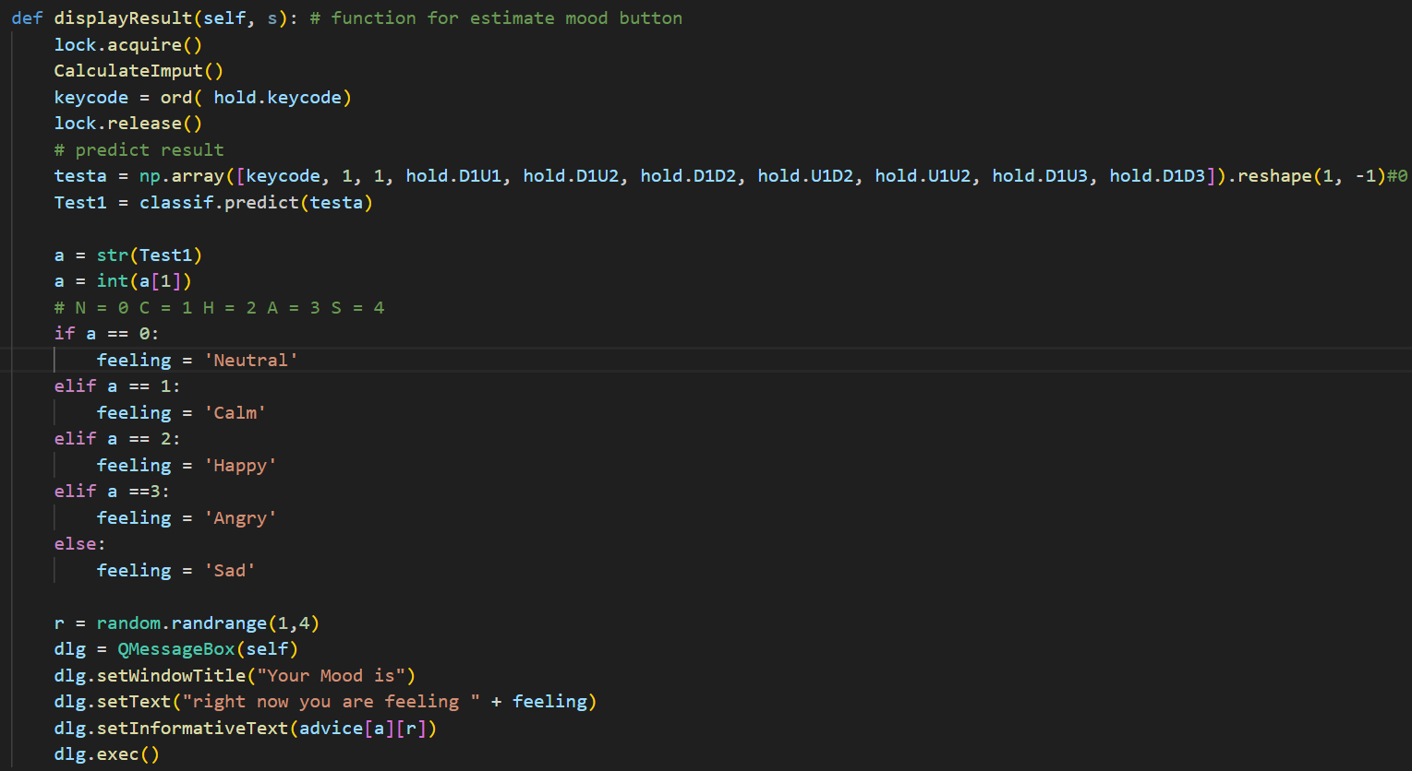 Figure 3.13 The prediction function

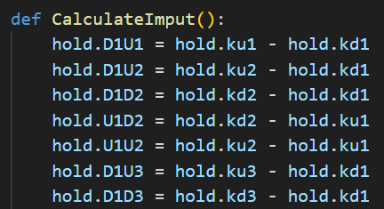
Figure 3.14 The function that calculate the data for a prediction.

3.8 Testing

To properly test the support tool and answer the main question of this project, it was necessary to not just measure the accuracy of the support tool but the usability and UX as well. To this end the methodology of testing was split into two main parts. The actual use of the support tool and the filling out of two surveys. The first half of testing was supervised by a researcher explaining the testing process, following the same method of collecting data in Maalej’s paper. The participants were shown an image from the IAPS dataset then the participant typed the given phrase and the prediction from the support tool was noted down. To ensure ethics were considered the participants were explicitly told that. “If the images made them too uncomfortable, they could stop testing and leave at any point.” However, the images used were carefully curated and verified by non-participants of the support tool testing. They were also verified to be inducing the wanted emotional state. Another important point about the images is that the testing participants were not told what emotion the image was trying to invoke. This way a purely natural response could be given. A response is not skewed by the expectation of what they think they should be feeling in that moment. This process was repeated for the five emotional states previously mentioned.

For the second section of testing a quantitative approach was taken due to there being many surveys and tools in the software development industry that could be used to get numerical data for qualitative concepts like likability and ease of use. These surveys have found baselines that have been verified over years of industry use. The support tool could then be directly compared to these baselines to discover if it is likely to be used regularly in a real-life setting. To test, these two surveys were chosen and made into a Google form. This form also contains the consent form and it was designed so the survey could not be accessed without consenting to testing. As previously stated, the two surveys used were the SUS and UEQ surveys. The SUS survey was used to measure the overall useability of the support tool. The UEQ does the same but for the user experience of using the tool.

3.9 Testing results processing

Both surveys use specific calculations to be scored and have specific score meanings. SUS operates on a simple calculation from a 5-point scale. For 1,3,5,7, and 9 the score is the scale position minus 1. For items 2,4,6,8 and 10, the score is 5 minus the scale position. Then the sum of the scores is multiplied by 2.5 to obtain the overall value of SUS. However, the overall value is a percentile, not a percentage. So, a score of 68 would put you around the 50th percentile. A good to great SUS score would be 70 upwards as can be seen in Figure 3.15. To get the final SUS score all the individual scores were calculated then the average was taken.
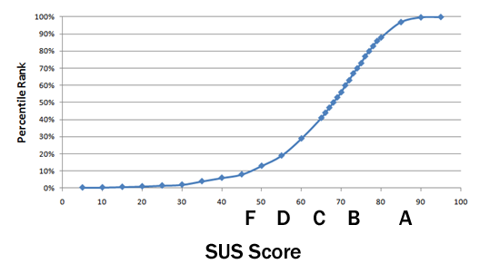
Figure 3.15 Graph showing SUS score against percentile (Measuringu.com, 2024)

The UEQ on the other hand is more complex as it deals with both pragmatic and hedonistic qualities, but the actual calculation is a simple two steps. The first is a simple conversion. The UEQ survey works on a 7-point scale from 1 to 7 this needs to be transformed to -3 to 3. This is because the survey questions are structured so that the positive qualities are on the right-hand side with negative qualities on the other. An example would be “Boring Exciting”. The second step is again to find the average or mean for each question. Here is where the scoring differs from SUS the resulting average is checked against a range of -0.8 to 0.8. anything below -0.8 is considered bad, anything between -0.8 and 0.8 is considered average, lastly anything above 0.8 is good. This is measured for each question and then the average for all the pragmatic questions and the hedonistic questions are found. Finally, these averages are checked against a benchmark made from 468 studies of various products. To simplify the process the creators of the UQE survey made an Excel-based data analysis tool. It is available on their website “https://www.ueq-online.org/.” (UEQ, 2018) and to use it you only need to enter the raw data. All the conversions and calculations are done for you then the results are shown in the graphs below. Due to this being a tool designed by the creators, this Project deemed its use appropriate. A point of note is that the short version of this survey was used. This was because for this project. It is not the support tool itself being tested it is if the technology behind the tool can be used in the context and if the public would want to use it.

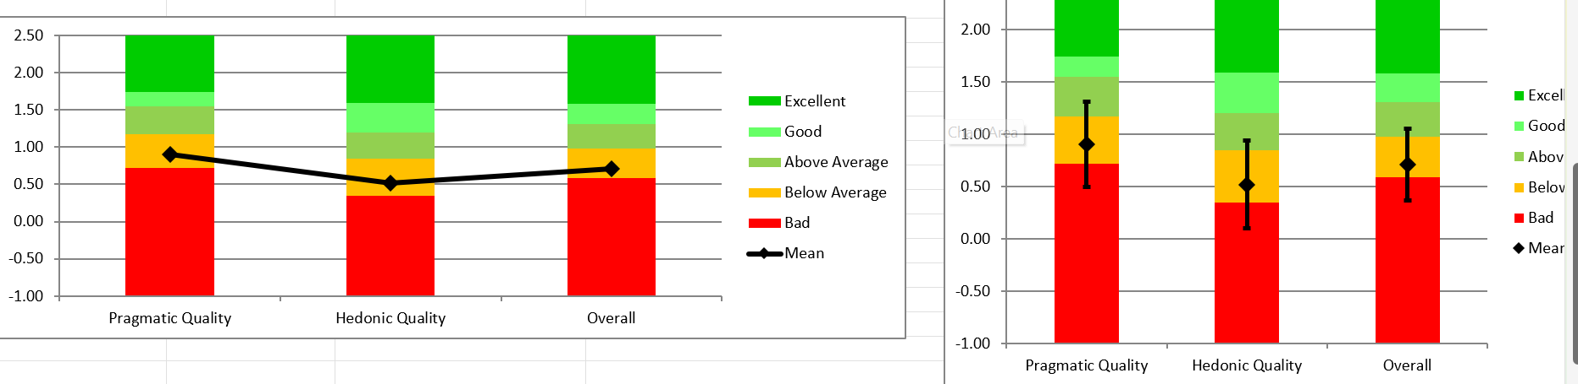
Figure 3.16 Graph from the UQE data analysis tool.

Chapter 4 Results
This chapter will be split into 3 main parts for ease of reading and to fully understand the results. The three parts are the results gained by testing the MLAs during development. The SUS survey results for the support tool. Lastly the results from the UEQ survey also for the support tool.

4.1 MLA development testing results
The tables shown in this section are summarised from raw data found in Appendix C

MLA | Error one loss  % | Individual  Class 0 test  Neutral  Majority  Rules | Individual  Class 1 test  Calm  Majority  Rules | Individual  Class 2 test  Happy  Majority  Rules | Individual  Class 3 test  Angry  Majority  Rules | Individual  Class 4 test  Sad  Majority  Rules | Test data accuracy  % | Training data accuracy  % | Main Classes Pre-dictions
Random Forrest | 68.94 | 0 | 2 | 1 | 3 | 4 | 31.06 | 99.91 | 1,2,3,4
K Nearest Neighbour | 68.76 | 2 | 2 | 4 | 3 | 4 | 31.24 | 42.53 | 1,2,3,4
Decision  Tree | 72.89 | 1 | 4 | 1 | 1 | 4 | 30.24 | 31.60 | 1,2,3,4
MLP | 74.53 | 1 | 1 | 1 | 1 | 1,2,4 | 25.47 | 26.04 | 1 and 2
Native Bayes | 78.92 | 3 | 3 | 2 | 2 | 3 | 21.08 | 21.52 | 2 and 4
Table 1 results of testing different MLAs

Table 1 shows the testing results from the initial stages of the MLAs development. The tables show the error, models accuracies on both training and testing data, the classes that were predicted the most and individual test for each class. For different kinds of MLA, the goal at this stage was to test multiple MLAs on the training data with data preprocessing as described in the first half of section 3.4. To find which MLA best fit the data and then tune the hyperparameters for better accuracy. As can be seen however all MLA have very low accuracies when trained on the data.

Different data  sets | Error one loss  % | Individual  Class 0 test  Neutral  Majority  Rules | Individual  Class 1 test  Calm  Majority  Rules | Individual  Class 2 test  Happy  Majority  Rules | Individual  Class 3 test  Angry  Majority  Rules | Individual  Class 4 test  Sad  Majority  Rules | Test data accuracy% | Training data accuracy  % | Main Classes Pre-dictions
3000 Rows Per  Class | 65.40 | 0 | 2 | 2 | 3 | 4 | 34.59 | 99.98 | 1,2,3,4
Class 0 Removed | 66.13 | N.A | 1 | 2 | 2 | 4 | 33.87 | 99.98 | 1,2,3,4
Positive  Negative  Classes  combined | 43.81 | 0 | 1 | 1 | 2 | 2 | 56.19 | 99.94 | 0
Keycode  Readded | 42.25 | 0 | 2 | 1 | 0 | 4 | 57.74 | 98.60 | 0
Keycode  Readded  Class 0  Removed | 70.24 | N.A | 4 | 1 | 3 | 2 | 29.76 | 98.17 | 1,2,3,4
Keycode  Readded  Positive  Negative  Classes  combined | 4313 | 1 | 1 | 1 | 2 | 0 | 56.87 | 98.88 | 0
Keycode Readded  Class 0  Removed  Positive  Negative  Classes  combined | 45.75 | N.A | 0 | 0 | 1 | 1 | 54.04 | 98.79 | 0
Table 2 results of testing different sets of training data

Table 2 shows the testing results from the second stage of the MLAs development. Here a single MLA was tested on different configurations of the training data. the columns are the same as Table 1 but for the tests for individual classes. Where the classes no longer exist, The result is marked non applicable. Also, for when classes are combined the test itself was still for one on the original classes. For example, when the positive and negative classes where combined. The tests themselves are still for class 0,1,2,3 and 4 but a correct set of predictions should be 0,1,1,2 and 2. As can be seen in Table 2 improvements were made but none were above 60%.

4.2 SUS Survey Results

Figure 4.1 Sus scores for each tester.

Fugure 4.1 above offers insight into the results for each of the testers' individual SUS surveys. By consulting figure 3.15 with the computed average of 81.65. It puts the support tool in the A grade range with it being in the 90 percentiles. However, a graph of the collected data for each question will better understand the questions and the tester's responses. Each question asked to the participants to agree or disagree with the given statement on a scale of 1-5. 1 being Strongly Disagree and 5 being 'Strongly Agree' with the statement.
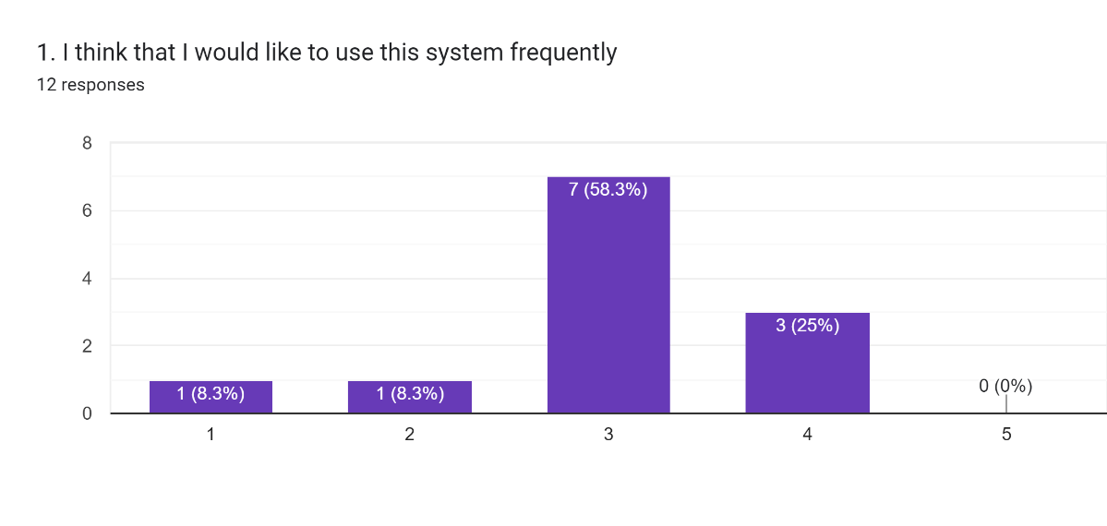
Figure 4.2 SUS survey Question 1

On average testers rated this question a score of 3 Indicating that testers were indifferent with using the system routinely.

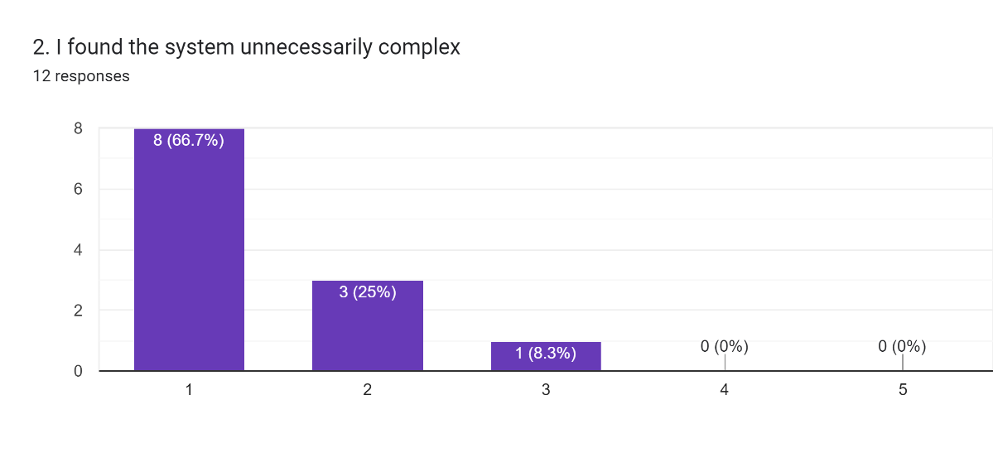
Figure 4.3 SUS survey Question 2

On average testers rated this question a score of 1.42 Indicating that testers found the system very simple to use.
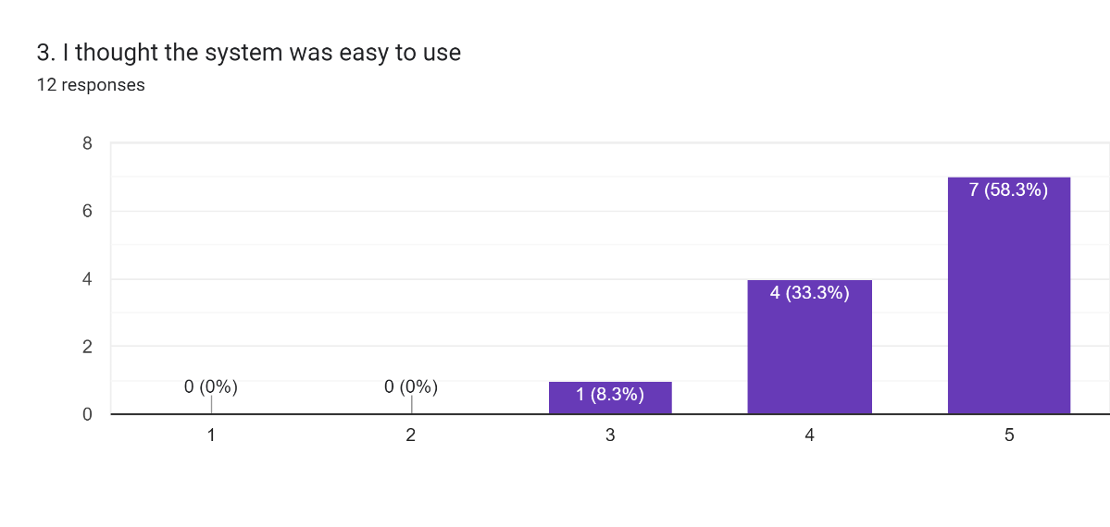
Figure 4.4 SUS survey Question 3

On average testers rated this question a score of 4.5 Indicating that testers found the system very easy to use.

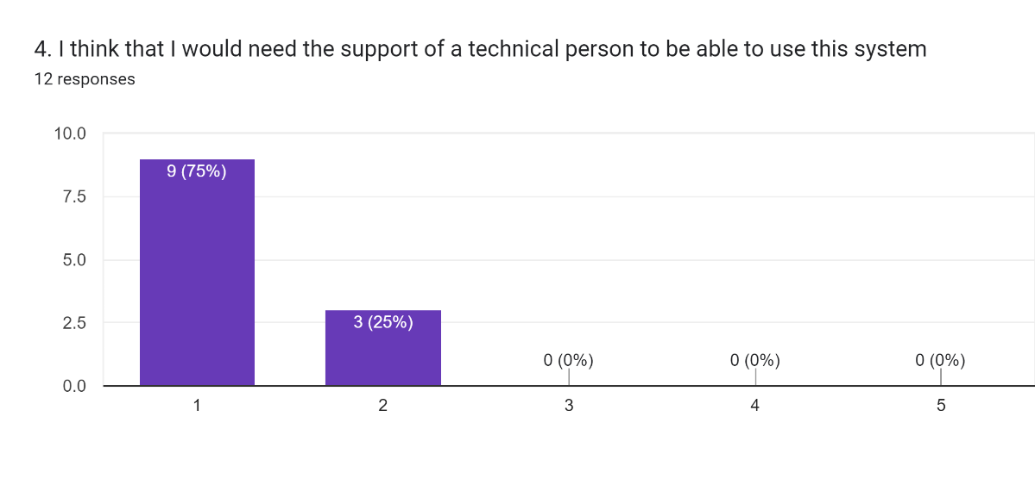Figure 4.5 SUS survey Question 4

On average testers rated this question a score of 1.5 Indicating that testers found that they could learn the system alone very easily.

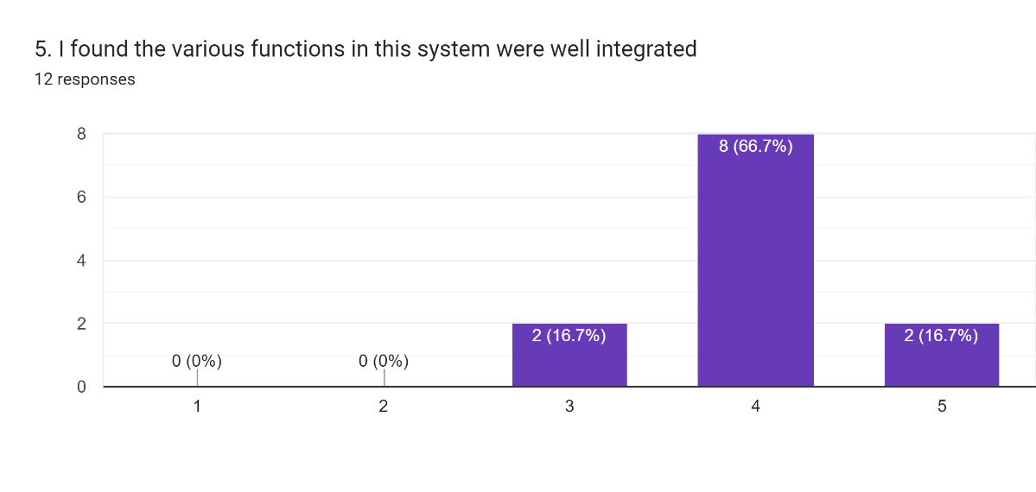
Figure 4.6 SUS survey Question 5

On average testers rated this question a score of 4 Indicating that testers found the system functions were well integrated.

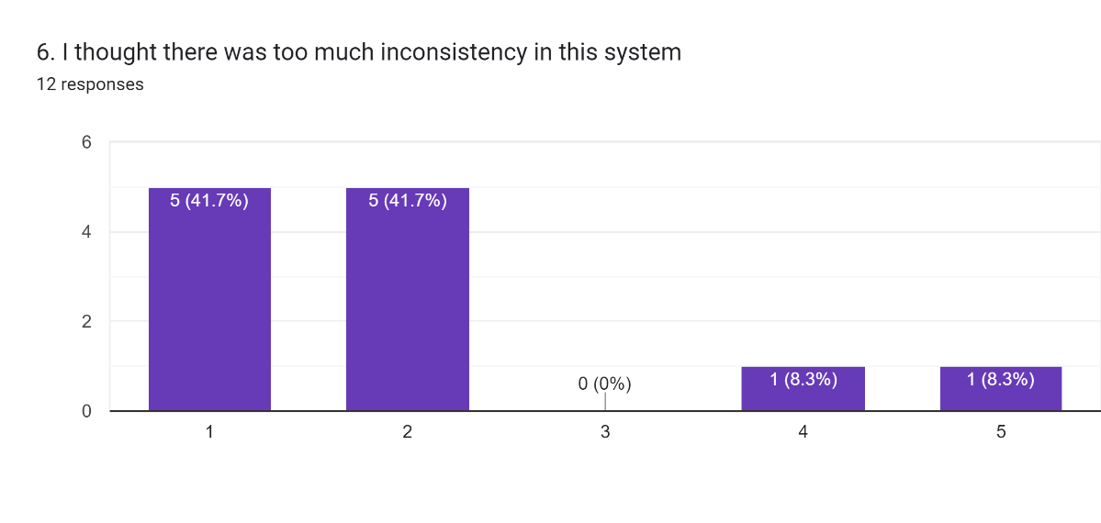
Figure 4.7 SUS survey Question 6

On average testers rated this question a score of 2 Indicating that testers found the system was not cluttered.

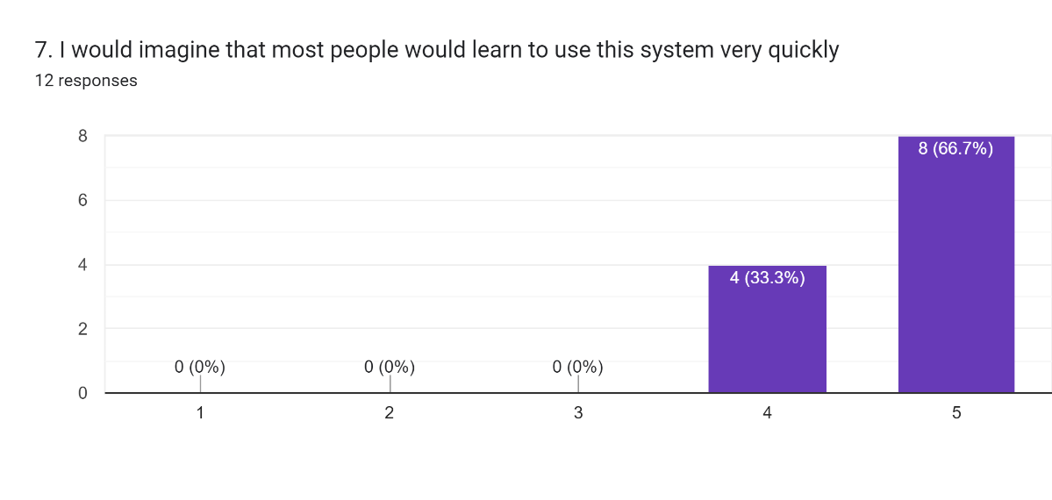
Figure 4.8 SUS survey Question 7

On average testers rated this question a score of 4.67 Indicating that testers found the system very easy to quickly learn.

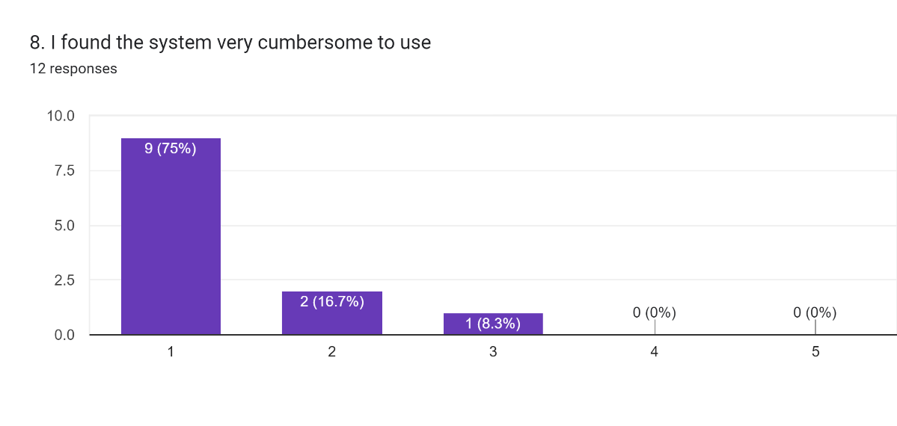
Figure 4.9 SUS survey Question 8

On average testers rated this question a score of 1 Indicating that testers found the system very easy to use.

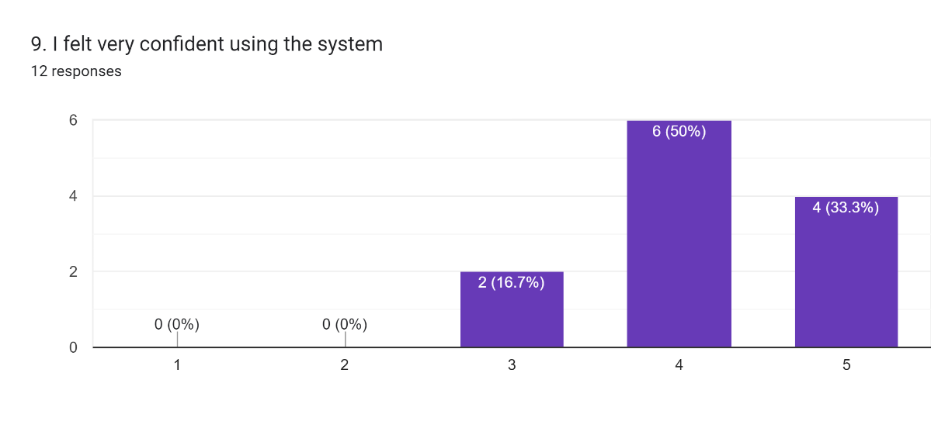
Figure 4.10 SUS survey Question 9

On average testers rated this question a score of 4.17 Indicating that testers felt they could use the system well.

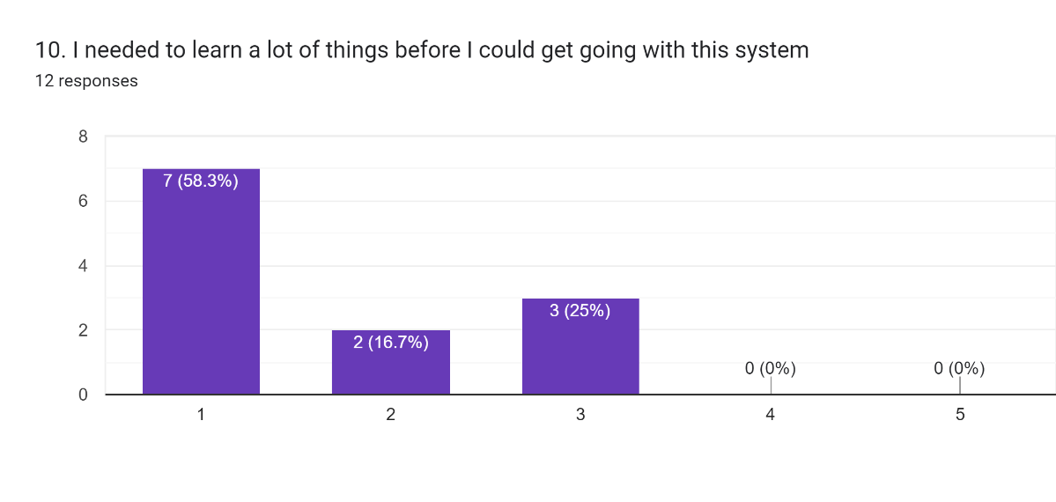
Figure 4.11 SUS survey Question 10

On average testers rated this question a score of 1.67 Indicating that testers found that they could use the system straight away.

4.3 UEQ Survey results

As previously stated, the UEQ survey has an official score calculator that does all conversions and calculations automatically. As can be seen in Figure 4.11 all but two qualities have a positive evaluation. With the hedonistic qualities of boring – exciting and usual – leading edge having neutral evaluations. However, as can be seen in Figure 4.12 all evaluations lean towards the positive.

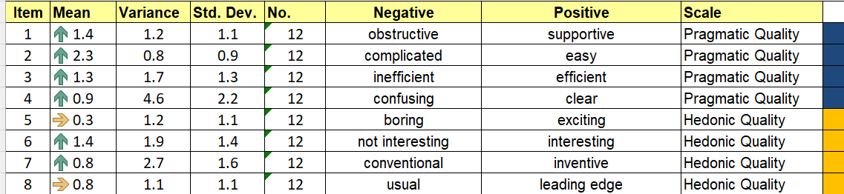
Figure 4.12 UEQ survey results breakdown.

Figure 4.13 UEQ survey mean of results.

Again, as previously mentioned the UEQ analysis tool has a function to check calculated values against a benchmark generated from hundreds of other products. As can be seen in Figure 4.13 the pragmatic quality and overall score are above average. However, the Hedonistic qualities scored below average.

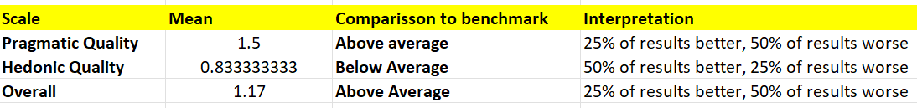
Figure 4.14 UEQ survey results against benchmark.

Figure 4.15 UEQ survey results against benchmark as Graph.

Chapter 5 Discussion

5.1 MLA
As the results show the MLA performs poorly, being only a 7.74% increase over a random prediction. However, the results of these tests guided development and could also lead to a handful of potential improvements. As mentioned earlier the first set of tests are shown in Appendix C, was to find the MLA that best fit the data. As shown there all of the confusion matrices for both testing and training data are either a mess of all possible predictions or predict all values for one or two specific classes. The precision-recall graphs where a straight diagonal line or a curve pointing down words showing bad to poor results. The ROC curves mostly showed slight positive curves for all classes, except MLP where class 0 neutral being heavily registered as false positive. I the end Random Forrest was chosen not just because it had the highest accuracy on the testing data but because it had close to 100% accuracy on the training data as well. A near-perfect prediction on training data is a clear sign of overfitting. This is not a bad thing, however as overfitting shows that the MLA is learning from the data. So, development continued with the use of Random Forest with plans to reduce overfitting to improve accuracy. The main method used to reduce overfitting was to tune hyperparameters, tuning the hyperparameters made a negligible difference. The tuning mainly consisted of changing the hyperparameters discussed in Chapter 3.5. Specifically n-estimators and max_features changing the number of estimators by 10 and changing the max number of features to “sqrt” or between 15 to 20. Having more than 90 estimators caused the development computer to crash. All of the above caused development to move to manipulating the training data, as there was no way to add more data as this project did not have access to the website Maalej used to collect the data. So, different data combinations were tested with some improvement found but none resulted in an accuracy of over 40%. The combinations were to limit the rows of the data to 3000 each, removing the neutral class combining classes together. Combining classes together did result in accuracies in the 50 to 60% range, it was ultimately decided that as the support tool was meant to help people identify and work through their feelings. Collapsing the tool to just feeling good or bad was seen by this Project as ultimately against purpose, as giving a specific feeling and advice on managing that feeling is better than just telling a person they are feeling bad and not giving them a reason why and not being able to give them a solution to make them feel better.

This was the point that the data pre-processing was revisited and improved, by adding the keyCode column back into the data it added more dimensionally to differentiate the classes. The same combinations were Retested but as can be seen, no improvement was made better than just re-adding keyCode. All of this contrasts heavily with Maalej's reported accuracy of 69% for Random Forest. As their paper does not detail the development of the MLA or their data pre-processing steps, there is no way for this project to recreate Maalej's results and with time constraints development was forced to move to the support tool. However, this project does have some hypotheses on how to improve MLA's accuracy. The first is to change the MLA from one multiclass classifier using the one vs all method to one using the one vs one method. The one vs one method instead of checking one class against all others at once. Creates an equivalent number of binary classifiers and individually checks each class against each other. Then once all the binary classifiers have made a prediction they are all collated and the class with the most predictions is the overall prediction. This process has been found to be able to better differentiate between classes finding patterns between two classes lost when comparing them all at once. The MLA use by the support tool will not need to change much as the one vs one implementation in sklearn spits the training data appropriately between the binary classifiers. It also collates the results as well so the support tool will not need be updated. The main downside is that the training time for the model would increase substantially. However, since the version the support tool uses is pretrained there should not be a time lag due to this. There may be an increase in prediction time due to the increased number of checks being done by the new model; however, it should not be substantial. Project believes that these changes would result in a more accurate support tool, due to the one vs one methods ability to better differentiate classes.

The second option this project sees is to personalize the training data to a single user. Maalej's data set consists of data collected from 124 users and through data exploration it was found that individual user's data consisted of only neutral rows and only one of the other classes, at a ratio of 2:1 which explains why the MLA is neutral biased. By personalizing the training data theoretically, the MLA will improve accuracy for that person, due to the data being less cluttered by contrasting data from multiple people. However, even with the poor performance of the MLA it does not prove or disprove the question of if ML can be used in the mental health industry. Within the papers and articles reviewed by this project, ML has proved that it is very capable of diagnosing mental illness and mood. Even if the support tool functions poorly it is not the whole picture when evaluating ML for its use in the mental health industry. If the support tool proves useable and the user experience makes the support tool desired by users for routine use, it proves that there is a place for the support tool in the industry.

5.2 SUS survey
The overall results seen in Table 3 show that the support tool is very usable ranking in the 90th percentile. With 11 testers giving a mark over 70, 8 marking over 80 and 2 marking over 90 This was despite the poor predictions showing promise for the wider public utilizing a similar kind of application. By breaking down the answers to the different questions more insights can be made. For example, question 1 asks if the user would use the app frequently. Having the majority of testers be indifferent could be interpreted as, the support tool is unsuited for the demographic of the testers. While the testers were young university students, they were not screened for mental health issues. A person who sees themselves as healthy won’t go see a healthcare professional. The same could be said for the support tool, a person with high emotional intelligence won’t use a tool to help them identify their emotions. As such the survey can be seen as flawed, however the SUS survey measures the usability of a product, so this potential flaw will be made apparent by the UEQ which measures the user experience. An unsuited application should score poorly. This will be discussed in the next section. An interesting example of the support tool being unsuited for a user is Tester 8. Tester 8’s SUS score is substantially lower than any of the other testers, with a score of 52.5, the second lowest being a score of 75. The reason for this was discovered after the test had occurred. Tester 8 was highly vocal about not trusting ML to learn to estimate their mood. This was an ethical issue discovered during research for this project. This distrust coloured their answers to both survey questions which ranged from neutral to negative.

Another example of distrust is question 6. The few testers who agreed with the system being too inconsistent all noted confusion when the support tool kept predicting neutral, when clearly, they were expecting to get a different result each time. This highlights the need for the MLA to be as accurate as possible, as an incorrect prediction could make the mental health issue worse. These results are vital, however as this kind of response is representative of the same kind of people and issues in the wider public. In order to fully evaluate the uses of ML for mental health for the general public, it is important to take these views and weigh them against the positive views. In this project, the positives highly outweigh the negatives, with the number of tester scores 80 and over being 9 to 3, showing that three-quarters of the testers thought the support tool had excellent useability. This level of usability makes sense as the support tool was designed to be as streamlined as possible to ensure testing was as smooth as possible. If this level of usability could be maintained into a fully integrated desktop app that holds people’s mental health info. From that info, from that information the user could be given the relevant advice and positive reinforcement they need. This project feels that ML could easily be successfully utilized in the mental health industry.

5.3 UEQ survey
As positive results of the UEQ survey shows a positive user experience, which in turn shows that people resonated with the support tool and would most likely use the tool. Confirming that a tool using ML to solve mental health issues has a place in the wider public. As discussed in Chapter 3 a data analysis tool was used to evaluate the results of the survey. As shown in Figure 4.12 all the results are positive however some of the result fall in the -0.8 to 0.8 bracket making them average. A full breakdown of all results is in Figure 5.1. To reclarify a mean below -0.8 is a poor score. A mean between -0.8 and 0.8 are considered average. Lastly a mean above 0.8 is a good evaluation from the tester.

Figure 5.1 UEQ survey results breakdown.

As can be seen, all the pragmatic results are middling positively reinforcing the results found by the SUS survey. Of primary interest are the results of the hedonistic qualities as these represent the user's qualitative experience with the app. As shown above two of the four qualities are average leaning towards middle. With question 5 being the lowest value representing whether or not people found the experience exciting. This result is somewhat expected as the purpose of the support tool is to inform rather than excite. Since the tool is designed to support serious mental health issues it needs to at least be neutral if not positive. This is evidenced by the results for question one on how supportive the experience is. Despite being a pragmatic question it shows that the support tool is succeeding at its main function of supporting the user’s mentality. All of this is taken into consideration for the overall score which was above average, when compared against the benchmark. The overall score was brought down by the hedonistic qualities which is just under above average. This breakdown of results show that the practical operation of the support tool is satisfactory but the experience of using the support tool is slightly lacking. This is due to the support tool being a proof of concept. This project is sure that if the UI and user interaction process was made to be user friendly the hedonistic qualities score could be improved. However, with an overall above average score the support tool scored better than 50% of other products, which is good news showing that there is a portion of the public that wants this kind of support tool.

This is not the end of the story, however. As hinted at earlier the pool of testers is very small. This is a problem as it is not a precise representation of the public as a whole. To account for this the data analysis tool implements a 95% confidence interval system as seen in Figure 4.14. As seen in the graph most of the intervals are spread across the good and above average sections for pragmatic qualities and overall shows that the public will generally see these aspects as positive. With the hedonistic qualities scoring lower the interval is spread from good all the way to bad completely covering below average. This shows the potential for people to heavily disagree over the hedonistic qualities of the support tool. A full breakdown of the confidence values for each question and scale can be found in Appendix E4. To ensure these confidence intervals are valid the tool also calculates the mean correlation between questions and Cronbach’s alpha values for both Pragmatic and hedonistic qualities. The pragmatic qualities scored 0.51 and 0.81 respectively, with the correlation scale going from 1 to -1 the pragmatic qualities have an average correlation. Using the rule of thumb for Cronbach’s alpha and using the threshold of 0.7 the pragmatic qualities are very correlated. Taking these values together shows that the testers generally agreed that the pragmatic qualities are generally positive. The hedonistic qualities results scored 0.59 and 0.85 meaning that the testers thought the hedonistic qualities were lacking. The full breakdown of correlations can be found in Appendix E5

One final point to flag. As the tool is designed for hundreds of rows of data it has a built-in system for detecting inconsistencies in a tester's answers. The analysis tool looks for repeated answers for each of the questions which shows the tester not showing proper engagement with the survey, hence giving bad data. The tool also checks for conflicting answers such as saying the product was easy to use but then saying it was complicated later. As can be seen in Figure 5.2 below 3 rows were flagged 1 for having all of its answers be 7 top marks and 2 rows for having inconsistent answers for the pragmatic questions.

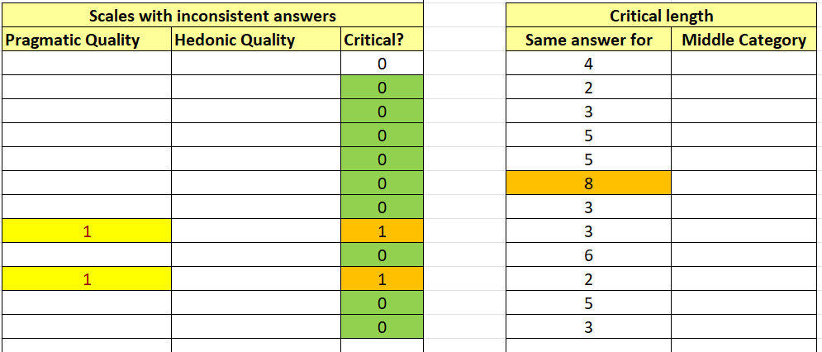
Figure 5.2 UEQ Survey inconsistencies.

The reason for not showing the results shown here in Chapter 4 was due to the pool of testers being so small. This project did not want to potentially miss precious viewpoints by removing the data from an already small data pool. However, to follow through with this Project’s due diligence the data was removed and the results found are discussed in the next paragraph.

Figure 5.3 UEQ Survey cleaned benchmark comparison.

As can be seen above in Figure 5.3 as expected Pragmatic Quality improved enough to move into the good range. Unexpectedly the hedonistic quality rose also raising the overall score. Despite all the categories now being positive they should be taken with a pinch of salt as the above graph was generated from only 9 rows of data. (The raw data for Figure 5.3’s graph can be found in Appendix F6.) There is further evidence to distrust the new results when the new correlation values are inspected. Pragmatic new scores were 0.40 and 0.73 with hedonistic being 0.33 and 0.67. (The full set of correlations can be seen in Appendix F5.) Showing that despite having better scores than the full data set the testers had little agreement on the qualities of the support tool. This highlights again the need for a bigger group of testers to get both the negative and positive viewpoints of the support tool. Despite this, the survey still leans towards the positive, still showing that there is an audience for the support tool. All graphs and values for the cleaned data can be found in Appendix Section F.

To summarise this sub-section, the UEQ survey did indeed prove that there is a small audience for the support tool as it is, proving that people do indeed want to use a mental health support tool using ML. The confidence intervals indicate that theoretically, the majority of people would give a positive review of the tool. In order to cement the public's view on the support tool more testers are needed to fill out the survey, however, improvements need to be made to the support tool's hedonistic qualities to improve the overall user experience, and hence appeal to the wider public.

Chapter 6 Conclusion and Future Work

The aim of the project was to evaluate the potential of using an MLA as a mental health support tool. The conclusion found was that there is a potential place for a mental health support tool using ML, in a small number of the general public. Whilst the MLA the support tool uses performs very poorly, the high usability and above average UE evidence a small portion of the public, would use an application like the support tool. There have been a number of papers and articles evidencing that ML can be used to predict emotions and diagnose accurately. As long as an accurate MLA can be developed this Project can see no reason why a support tool like this cannot be used in the real world. The mere fact that the UEQ showed positive results shows that users enjoyed using the support tool and would use it repeatedly if it were easily accessible, as shown by previous research to ensure that those who need it get the best help. The support tool would need to be monitored by mental health professionals to ensure that the positive outcomes are achieved.

If a support tool like this was widely available and recommended by doctors, it would allow people with minor mental health issues with a low emotional intelligence to better understand themselves and lead a happier life, which in turn could free up vital personnel and resources to concentrate on more complex cases. This support tool is potentially a small contribution to the solution to the ongoing mental health crisis.

6.1 Future Improvements

This Project succeeded in its main goal of evaluating ML as a mental health support tool but as discussed previously throughout this dissertation there are several points of improvement, both for the support tool itself and the testing of the support tool. The biggest and most obvious flaw of the support tool is the MLA it uses for predictions. As discussed, numerous times there were major problems while developing the MLA, leading to timetable pushbacks until ultimately development had to be put on hold to develop the support tool itself. If this Project was to be repeated or built upon there are two hypotheses that should be tested that may improve the accuracy of the MLA. One is changing the MLA from a multiclass classifier using one vs many to one using the one vs one method. This would not require making major changes to the support tool only the MLA it uses but it may cause the support tool to run slower when predicting. However, research has shown that the one vs one method, can be better are discerning the differentiating patterns of one combination of classes over a different pair. This method could also solve the neutral class imbalance in the data set as one vs many is known to be susceptible to class imbalancing in the training data.

The other is to further develop the support tool to continually learn the user's KD. Looping back to Chapter 2 section 3 likening KD to handwriting means that a person's KD is just as unique as their handwriting. To account for this a fully integrated support tool was to be developed. This Project suggests that the initial version used an MLA generalised to the public. Then as the user continually utilises the tool it records their KD and slowly filters out the general public’s data until the MLA just utilises the user's KD data to make predictions. The users of the tool should be made aware of this to account for ethical concerns. However, this level of personalization is vital as no person’s mental health issues are the same as another and personalized treatment or advice should be tailored accordingly. This support tool is potentially an answer to this problem.

Moving on from the MLA to the support tool itself and its testing. As the results of the UEQ survey showed the qualitative aspects of the support tool were lacking. This again was due to the support tool being developed to be a proof of concept only having the bare minimum to allow the testers to experience the technology. To evaluate the support tool as a fully developed desktop application it should at the very least look like a fully developed app. This would mean redeveloping the UI and expanding functionality tasks, this project didn't have a timescale for this. By doing this the UE should be improved hence appealing to more potential users who would benefit from a support tool like this, being able to enjoy engaging with it and getting the help they need. Finally, as discussed in Chapter 5 section 3 the number of testers needs to be drastically expanded to be able to achieve more accurate results by getting as many differing viewpoints of the support tool as possible. To ensure that with a certainty people want an application like the support tool. This Project suggests having approximately 200 testers to maximize potential opinion data gathered.

List of References
‌ A Maalej and I Kallel. (2020). Does Keystroke Dynamics tell us about Emotions? A Systematic Literature Review and Dataset Construction. [online] Available at: https://ieeexplore.ieee.org/document/9155004/authors#authors [Accessed 6 Nov. 2023].

‌Brooke, J. (1995). SUS: A quick and dirty usability scale. [online] ResearchGate. Available at: https://www.researchgate.net/publication/228593520_SUS_A_quick_and_dirty_usability_scale. [Accessed:11 March 2024]
Bryn Farnsworth, (2020). The International Affective Picture System [Explained and Alternatives] - iMotions. [online] Available at: https://imotions.com/blog/learning/research-fundamentals/iaps-international-affective-picture-system/. [Accessed 6 Mar. 2024].
Díaz-Oreiro, I., López, G., Quesada, L. and Guerrero, L.A. (2021). UX Evaluation with Standardized Questionnaires in Ubiquitous Computing and Ambient Intelligence: A Systematic Literature Review. Advances in Human-Computer Interaction, [online] 2021, p.e5518722. doi: https://doi.org/10.1155/2021/5518722. [Accessed 16 Feb. 2024].

Kim, J., Lee, J., Park, E. and Han, J. (2020). A deep learning model for detecting mental illness from user content on social media. [online] Available at: https://doi.org/10.1038/s41598-020-68764-y. [Accessed 29 Feb. 2024].

Maalej, A. (2020). A TYPING BIOMETRIC (KEYSTROKE DYNAMICS) DATASET WITH EMOTION LABELS CREATED USING COMPUTER KEYBOARDS. [online] IEEE DataPort. Available at: https://ieee-dataport.org/open-access/emosurv-typing-biometric-keystroke-dynamics-dataset-emotion-labels-created-using#:~:text=EmoSurv%20is%20a%20dataset%20containing,%2C%20Sadness%2C%20and%20Neutral%20state. [Accessed 6 Nov. 2023]. Data set link

Martin Fitzpatrick, updated P.C. applications with Q. (2021). Create your first PyQt6 app in Qt Creator. [online] Python GUIs. Available at: https://www.pythonguis.com/tutorials/pyqt6-first-steps-qt-designer/ [Accessed 4 Apr. 2024].

Measuringu.com. (2024). Available at: https://measuringu.com/images/sus-curve.png [Accessed 22 Mar. 2024].

Morley, J., Machado, C.C.V., Burr, C., Cowls, J., Joshi, I., Taddeo, M. and Floridi, L. (2020). The ethics of AI in health care: A mapping review. Social Science & Medicine, [online] 260(113172), p.113172. Available at: https://www.sciencedirect.com/science/article/pii/S0277953620303919. [Accessed 6 Nov. 2023].

Python GUIs. (2021). PyQt6 Tutorial 2023, Create Python GUIs with Qt. [online] Available at: https://www.pythonguis.com/pyqt6-tutorial/. [Accessed 23 March. 2024].

Readthedocs.io. (2021). Handling the keyboard — pynput 1.7.3 documentation. [online] Available at: https://pynput.readthedocs.io/en/latest/keyboard.html. [Accessed 21 March 2024]

Rocheteau, E. (2023). On the role of artificial intelligence in psychiatry. The British Journal of Psychiatry, [online] 222(2), pp.54–57. doi: https://doi.org/10.1192/bjp.2022.132. [Accessed 16 Feb. 2024].

‌ Rykov, Y., Thach, T.-Q., Bojic, I., Christopoulos, G. and Car, J. (2021). Digital Biomarkers for Depression Screening With Wearable Devices: Cross-sectional Study With Machine Learning Modeling. JMIR mHealth and uHealth, 9(10), p.e24872. doi: https://doi.org/10.2196/24872. [Accessed 29 Feb. 2024].
Schrepp, M. (2023). User Experience Questionnaire Handbook. [online] volume 11, p.13. Available at: https://www.ueq-online.org/ [Accessed 10 Apr. 2024].‌

Scikit-learn.org. (2019). scikit-learn Logo [online] Available at: https://scikit-learn.org/stable/. [Accessed 21 Mar. 2024]

Siedlecka, E. and Denson, T.F. (2018). Experimental Methods for Inducing Basic Emotions: A Qualitative Review. Emotion Review, 11(1), pp.87–97. doi: https://doi.org/10.1177/1754073917749016 . [Accessed 16 Feb. 2024].

The British Medical Association is the trade union and professional body for doctors in the UK. (n.d.). Mental health pressures data analysis. [online] Available at: https://www.bma.org.uk/advice-and-support/nhs-delivery-and-workforce/pressures/mental-health-pressures-data-analysis#:~:text=Between%202017%20and%202022%2C%20rates.[Accessed 03 Oct. 2023].

UEQ (2018). User experience questionnaire (UEQ). [online] Ueq-online.org. Available at: https://www.ueq-online.org/. [Accessed:11 March 2024]

‌Vesel, C. (2020). Effects of mood and aging on keystroke dynamics metadata and their diurnal patterns in a large open-science sample: A BiAffect iOS study. [online] National Library of Medicine. Available at: https://www.ncbi.nlm.nih.gov/pmc/articles/PMC7647317/ [Accessed 10 Oct. 2023].

www.imageemotion.org. (n.d.). Image Emotion - download image data-set. [online] Available at: https://www.imageemotion.org/ [Accessed 6 Mar. 2024].

Appendices
Appendix A – Gantt Chart
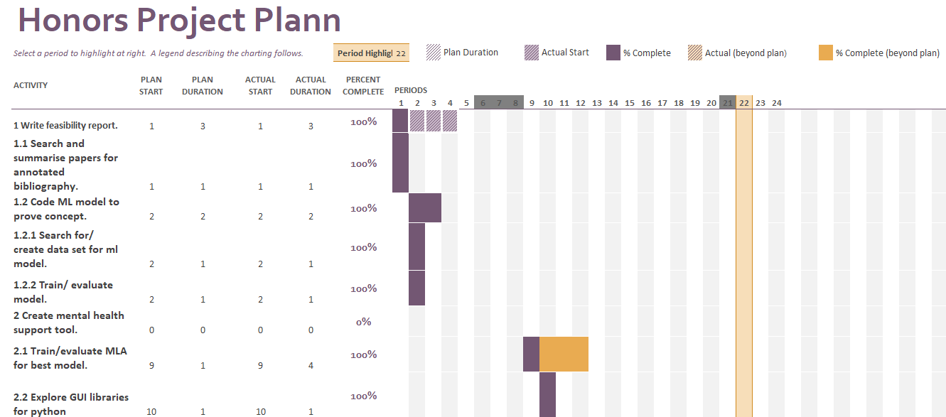
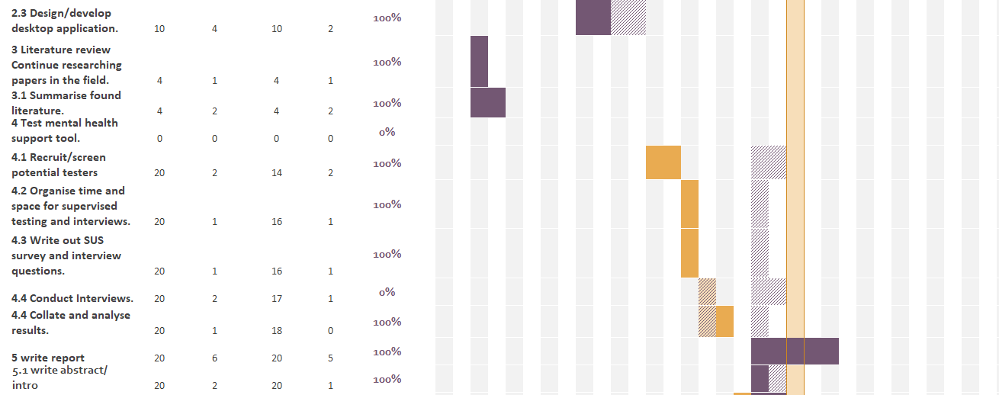

Appendix B – Support Tool UI Designs

1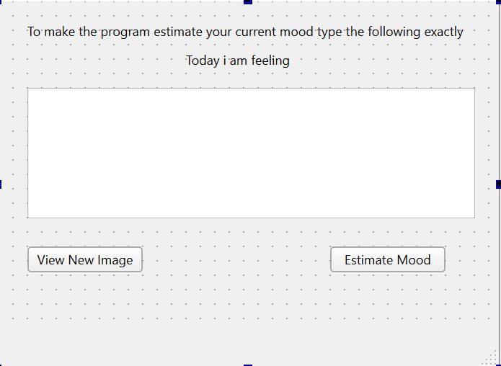

2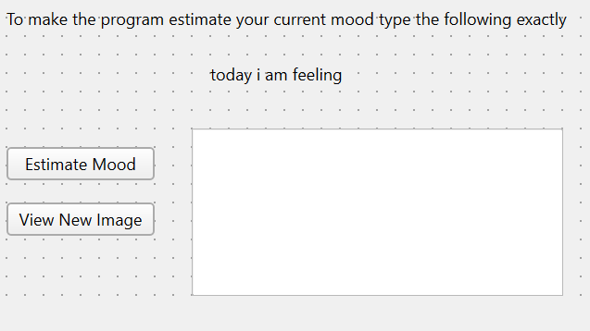

3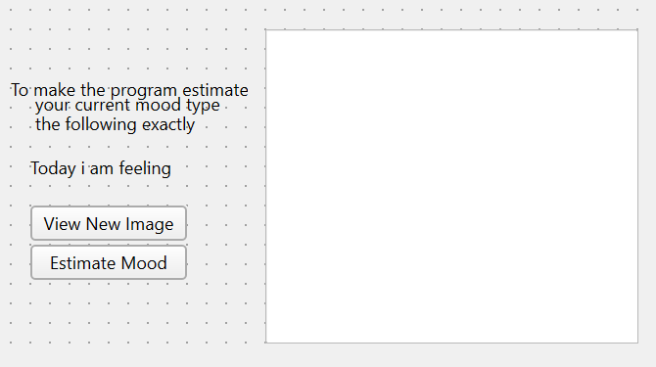

4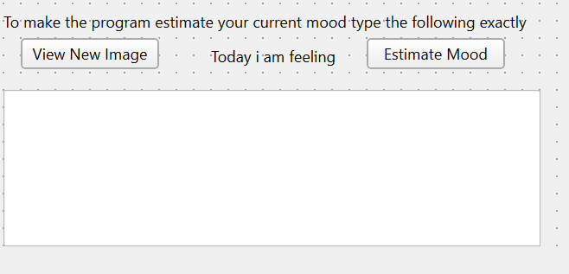

Appendix C – MLA development test results
Random Forest
Graph layouts
[ROC curves] [testing confusion matrix]
[Training confusion matrix] [precision recall curve]
1
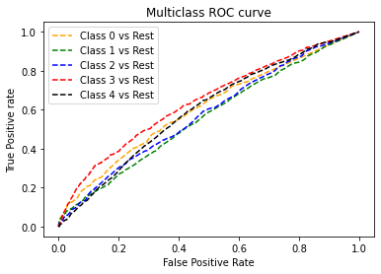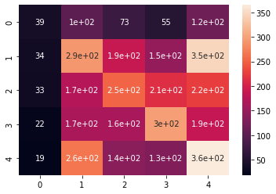
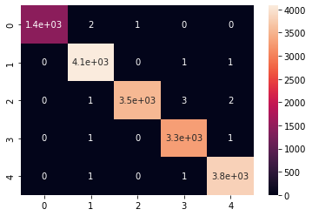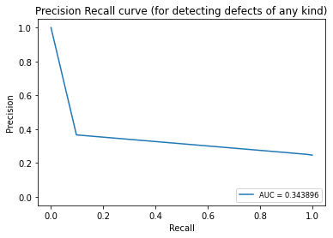
Error one loss: 0.6920029710324338
the first test should value 0. clasified as [0]
the second test should value 2. clasified as [2]
the third test should value 1. clasified as [1]
the forth test should value 3. clasified as [3]
the fifth test should value 4. clasified as [4]
test Result: Accuracy Score: 30.80%
train Result: Accuracy Score: 99.91%
2
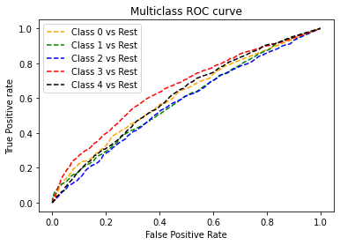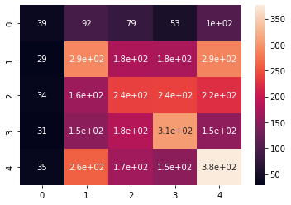
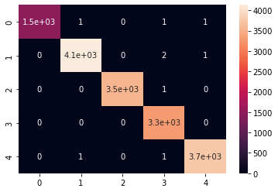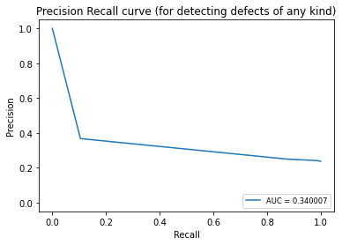
Error one loss: 0.6905174548155484
the first test should value 0. clasified as [1]
the second test should value 2. clasified as [2]
the third test should value 1. clasified as [4]
the forth test should value 3. clasified as [3]
the fifth test should value 4. clasified as [4]
test Result: Accuracy Score: 30.95%
train Result: Accuracy Score: 99.94%

3
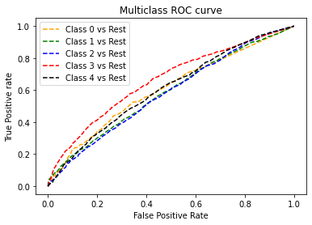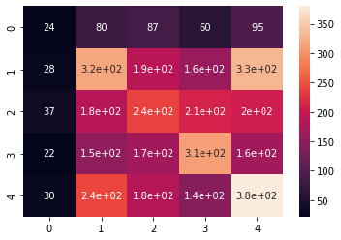
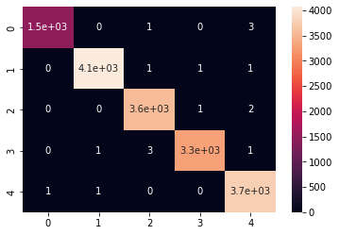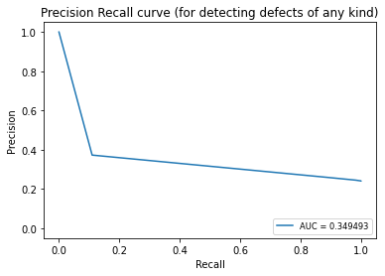
Error one loss: 0.6855657340925971
the first test should value 0. clasified as [0]
the second test should value 2. clasified as [2]
the third test should value 1. clasified as [1]
the forth test should value 3. clasified as [3]
the fifth test should value 4. clasified as [4]
test Result: Accuracy Score: 31.44%
train Result: Accuracy Score: 99.89%

averages
error one loss: 0.6893620533135264
test results: 31.06
train results: 99.91
the training data confusion matrix makes it look like it is over tuning
the main classes predicted are all but class 0

KNN
1
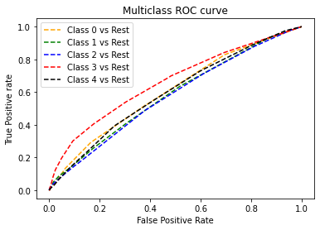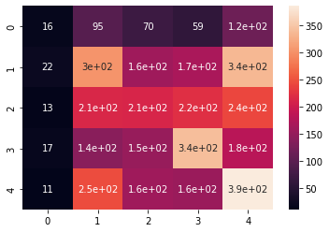
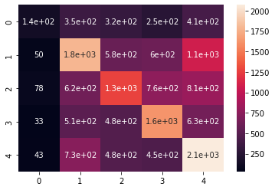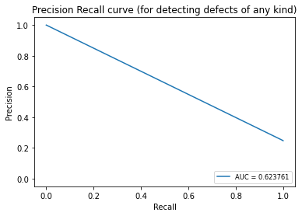
Error one loss: 0.6882891804902204
the first test should value 0. clasified as [2]
the second test should value 2. clasified as [2]
the third test should value 1. clasified as [4]
the forth test should value 3. clasified as [3]
the fifth test should value 4. clasified as [4]
test Result: Accuracy Score: 31.17%
train Result: Accuracy Score: 42.59%

2
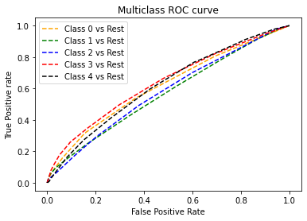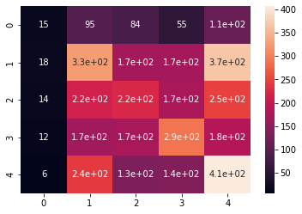
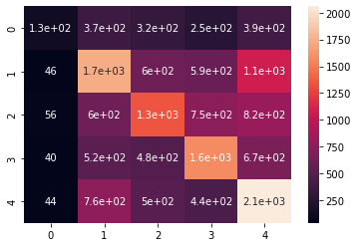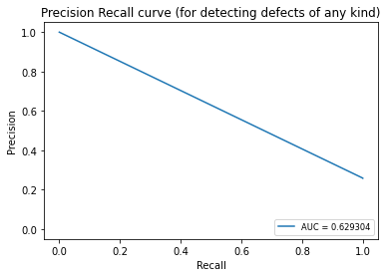
Error one loss: 0.68729883634563
the first test should value 0. clasified as [0]
the second test should value 2. clasified as [2]
the third test should value 1. clasified as [4]
the forth test should value 3. clasified as [3]
the fifth test should value 4. clasified as [4]
test Result: Accuracy Score: 31.27%
train Result: Accuracy Score: 42.36%

3
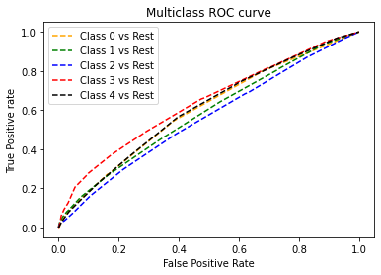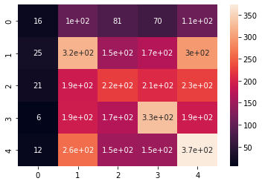
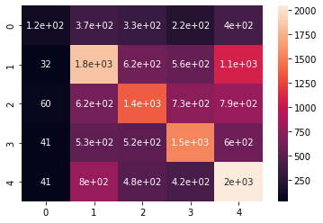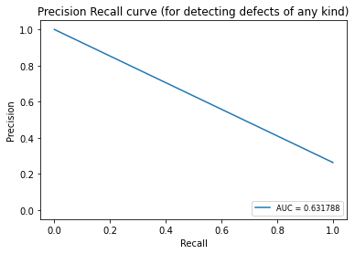
Error one loss: 0.68729883634563
the first test should value 0. clasified as [2]
the second test should value 2. clasified as [2]
the third test should value 1. clasified as [4]
the forth test should value 3. clasified as [3]
the fifth test should value 4. clasified as [4]
test Result: Accuracy Score: 31.27%
train Result: Accuracy Score: 42.64%

averages
error one loss: 0.6876289510604935
test results: 31.24
train results: 42.53
the estimations are all over the place except for class 0 neutral

Decision trees
1
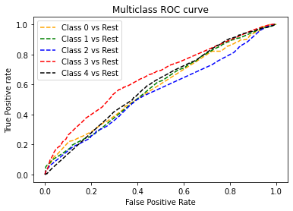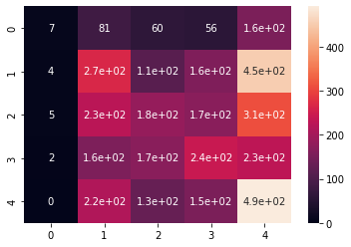
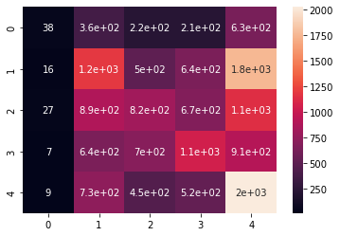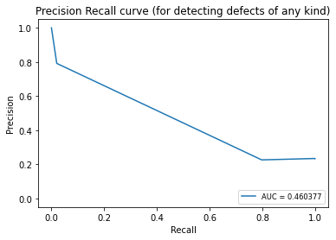
Error one loss: 0.7048774449121069
the first test should value 0. clasified as [3]
the second test should value 2. clasified as [4]
the third test should value 1. clasified as [3]
the forth test should value 3. clasified as [3]
the fifth test should value 4. clasified as [4]
test Result: Accuracy Score: 29.51%
train Result: Accuracy Score: 31.70%

2
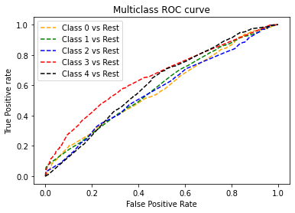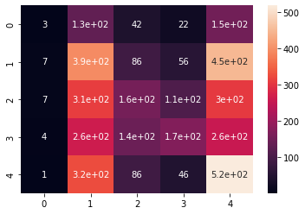
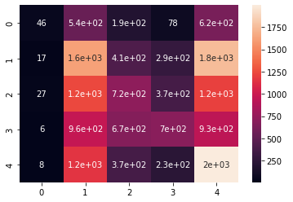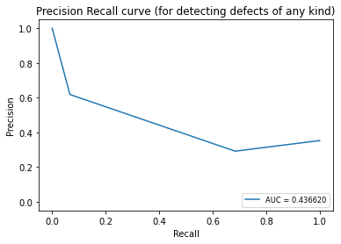
Error one loss: 0.6922505570685813
the first test should value 0. clasified as [1]
the second test should value 2. clasified as [4]
the third test should value 1. clasified as [1]
the forth test should value 3. clasified as [1]
the fifth test should value 4. clasified as [4]
test Result: Accuracy Score: 30.77%
train Result: Accuracy Score: 31.43%

3
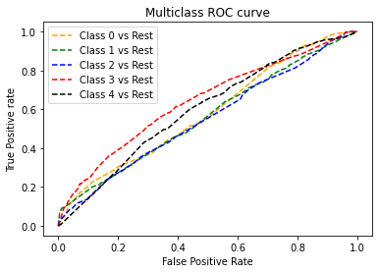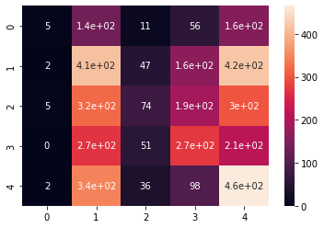
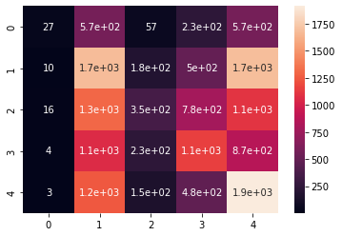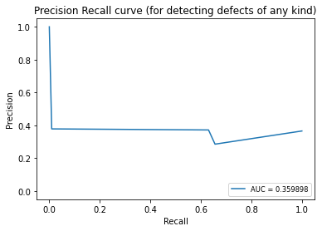
Error one loss: 0.6957167615746471
the first test should value 0. clasified as [1]
the second test should value 2. clasified as [4]
the third test should value 1. clasified as [1]
the forth test should value 3. clasified as [1]
the fifth test should value 4. clasified as [4]
test Result: Accuracy Score: 30.43%
train Result: Accuracy Score: 31.67%

averages
error one loss: 0.7287832521801324
test results: 30.24
train results: 31.60
the estimations are all over the place except for class 0 neutral

MLP Classifier
1
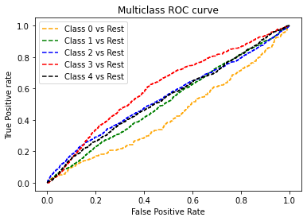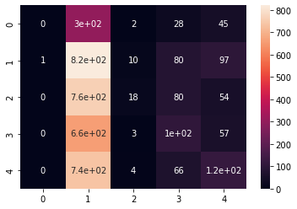
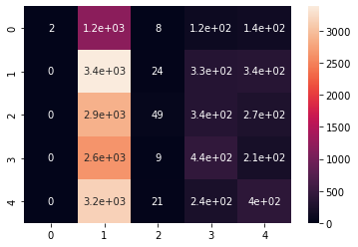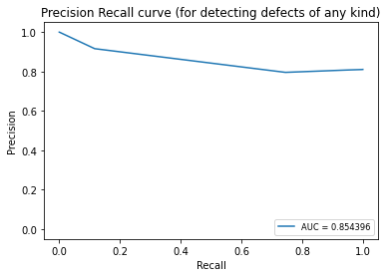
Error one loss: 0.7378063877197326
the first test should value 0. clasified as [1]
the second test should value 2. clasified as [1]
the third test should value 1. clasified as [1]
the forth test should value 3. clasified as [1]
the fifth test should value 4. clasified as [4]
test Result: Accuracy Score: 26.22%
train Result: Accuracy Score: 26.46%

2
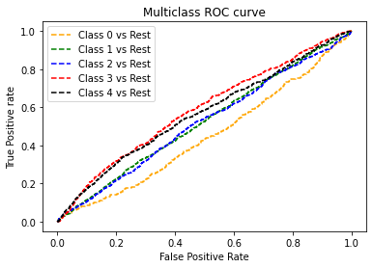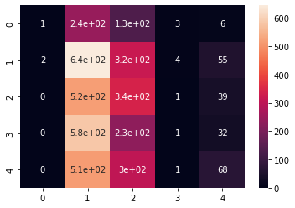
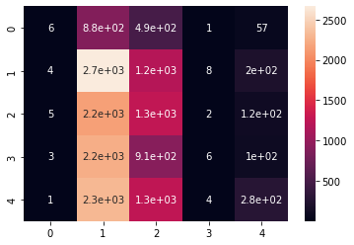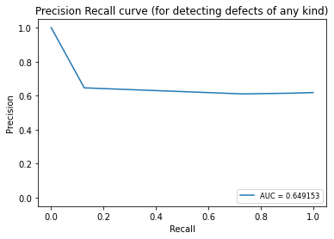
Error one loss: 0.7387967318643229
the first test should value 0. clasified as [1]
the second test should value 2. clasified as [1]
the third test should value 1. clasified as [2]
the forth test should value 3. clasified as [1]
the fifth test should value 4. clasified as [2]
test Result: Accuracy Score: 26.12%
train Result: Accuracy Score: 26.15%

3
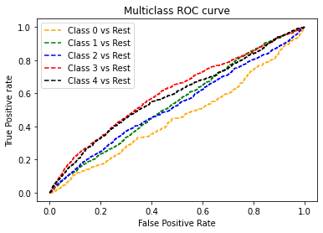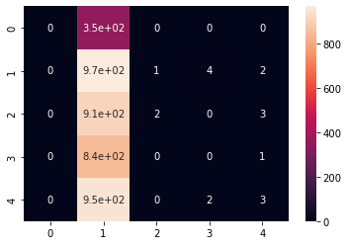
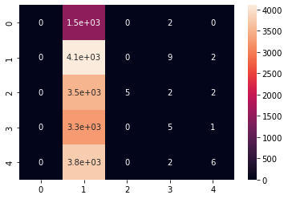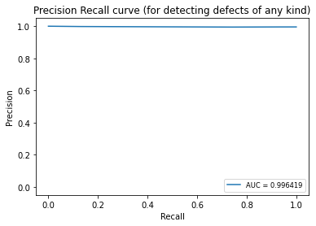
Error one loss: 0.7593463728645704
the first test should value 0. clasified as [1]
the second test should value 2. clasified as [1]
the third test should value 1. clasified as [1]
the forth test should value 3. clasified as [1]
the fifth test should value 4. clasified as [1]
test Result: Accuracy Score: 24.07%
train Result: Accuracy Score: 25.52%

averages
error one loss: 0.7453164974828753
test results: 25.47
train results: 26.04
regularly estimated to 2 main classes 1 and 2

Native Bayes
1
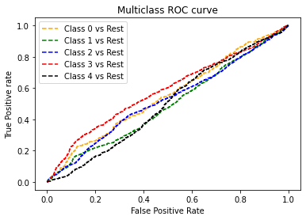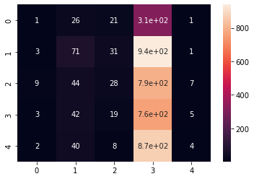
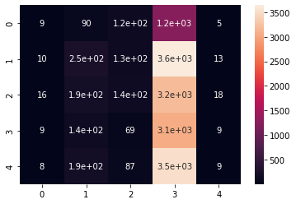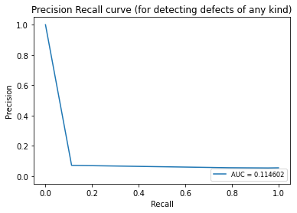
Error one loss: 0.7853429066600643
the first test should value 0. clasified as [3]
the second test should value 2. clasified as [3]
the third test should value 1. clasified as [2]
the forth test should value 3. clasified as [2]
the fifth test should value 4. clasified as [3]
test Result: Accuracy Score: 21.47%
train Result: Accuracy Score: 21.43%

2
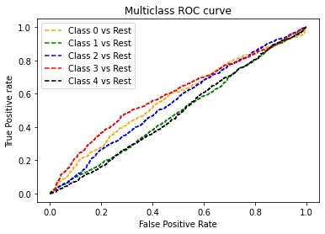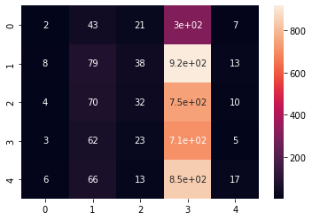
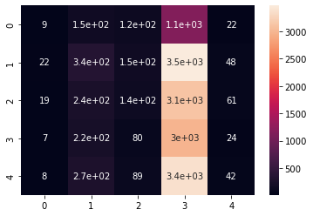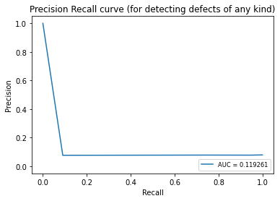
Error one loss: 0.7925229017083436
the first test should value 0. clasified as [3]
the second test should value 2. clasified as [3]
the third test should value 1. clasified as [2]
the forth test should value 3. clasified as [2]
the fifth test should value 4. clasified as [3]
test Result: Accuracy Score: 20.75%
train Result: Accuracy Score: 21.73%

3
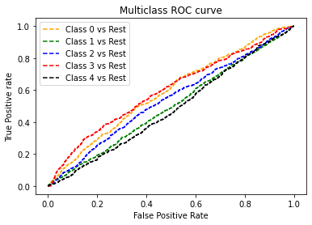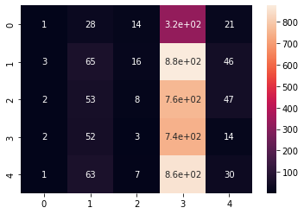
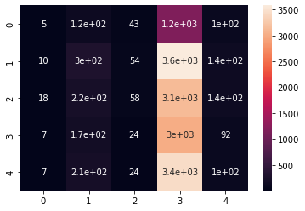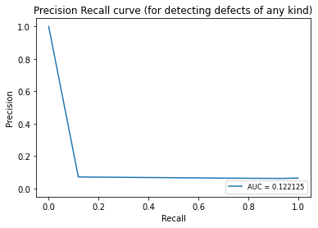
Error one loss: 0.7897994553107205
the first test should value 0. clasified as [3]
the second test should value 2. clasified as [3]
the third test should value 1. clasified as [4]
the forth test should value 3. clasified as [4]
the fifth test should value 4. clasified as [3]
test Result: Accuracy Score: 21.02%
train Result: Accuracy Score: 21.41%

averages
error one loss: 0.789221754559709
test results: 21.08
train results: 21.52
regularly estimated to 2 main classes 2 and 4

Different training data
Limiting the data to around 3000 rows per class
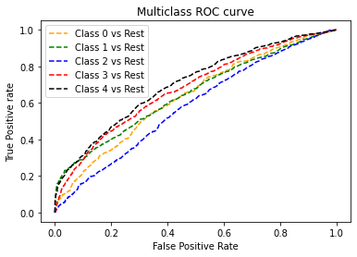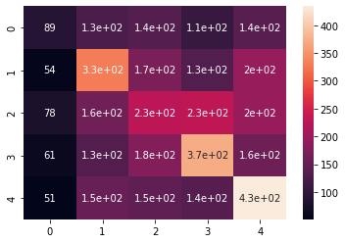
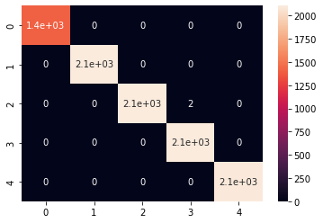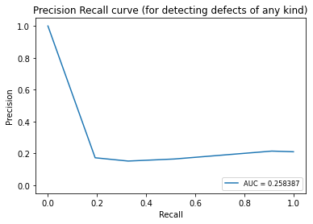
Error: 0.6540566262193671
the first test should value 0. clasified as [0]
the second test should value 2. clasified as [2]
the third test should value 1. clasified as [2]
the forth test should value 3. clasified as [3]
the fifth test should value 4. clasified as [4]
test Result: Accuracy Score: 34.59%
train Result: Accuracy Score: 99.98%
the main classes predicted all but class 0

neutral removed
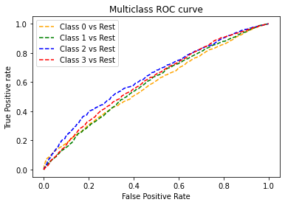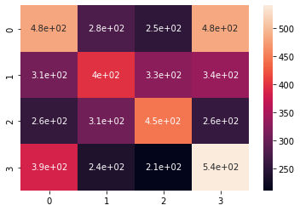
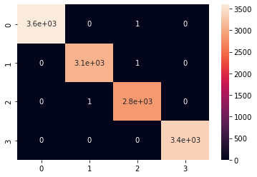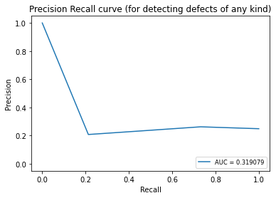
Error: 0.6612844702467344
the second test should value 1. clasified as [1]
the third test should value 0. clasified as [2]
the forth test should value 2. clasified as [2]
the fifth test should value 3. clasified as [3]
test Result: Accuracy Score: 33.87%
train Result: Accuracy Score: 99.98%
the main classes predicted all classes

collapsed
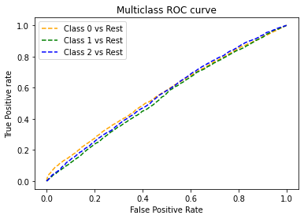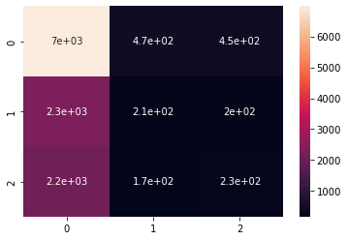
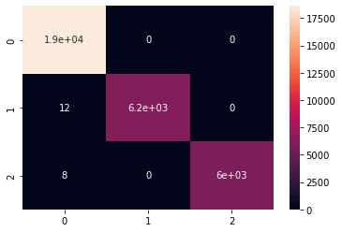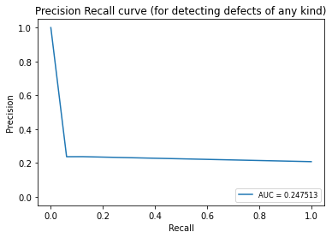
Error: 0.4381154370549917
the first test should value 0. clasified as [0]
the second test should value 1. clasified as [1]
the third test should value 1. clasified as [1]
the forth test should value 2. clasified as [2]
the fifth test should value 2. clasified as [2]
test Result: Accuracy Score: 56.19%
train Result: Accuracy Score: 99.94%
the main class predicted class 0

KeyCode feature added back to data set
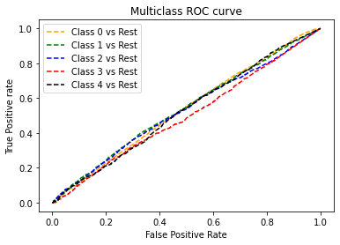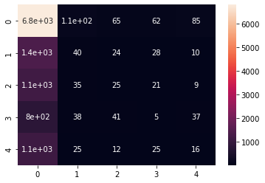
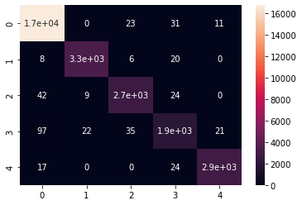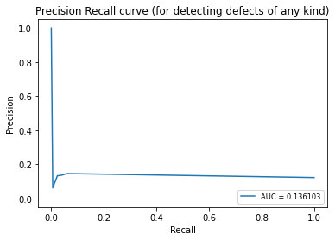
Error: 0.42255172991538914
the first test should value 0. clasified as [0]
the second test should value 2. clasified as [2]
the third test should value 1. clasified as [1]
the forth test should value 3. clasified as [0]
the fifth test should value 4. clasified as [4]
test Result: Accuracy Score: 57.74%
train Result: Accuracy Score: 98.60%
the main classes predicted class 0

keycode added n removed
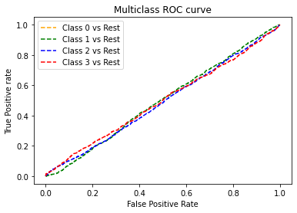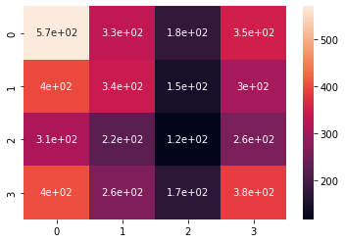
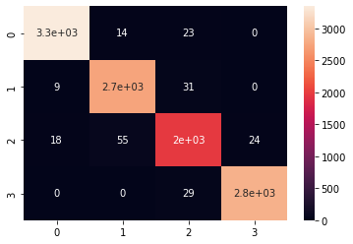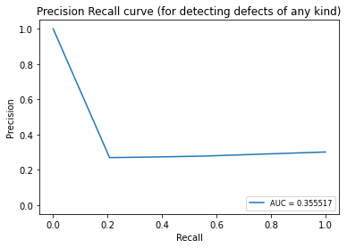
Error: 0.7023959646910467
the second test should value 1. clasified as [4]
the third test should value 0. clasified as [1]
the forth test should value 2. clasified as [3]
the fifth test should value 3. clasified as [2]
test Result: Accuracy Score: 29.76%
train Result: Accuracy Score: 98.17%
the main classes predicted all classes

keycode collapsed
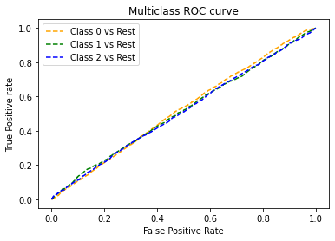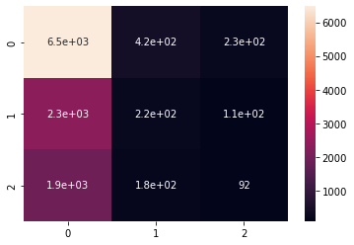
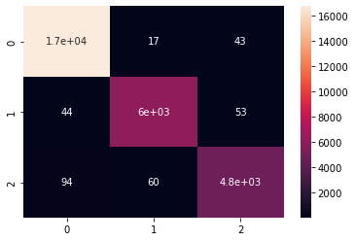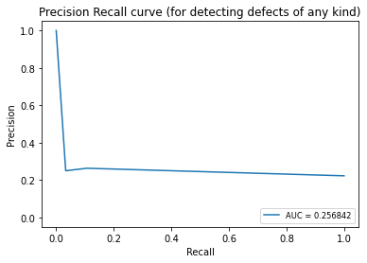

Error: 0.4312641367177683
the first test should value 0. clasified as [1]
the second test should value 1. clasified as [1]
the third test should value 1. clasified as [1]
the forth test should value 2. clasified as [2]
the fifth test should value 3. clasified as [0]
test Result: Accuracy Score: 56.87%
train Result: Accuracy Score: 98.88%
the main classes predicted class 0

keycode binarized
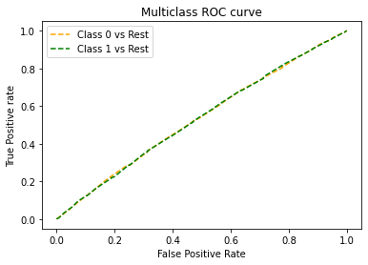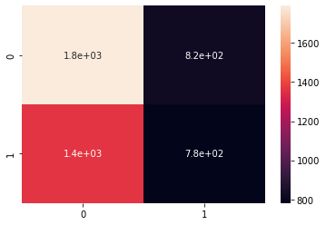
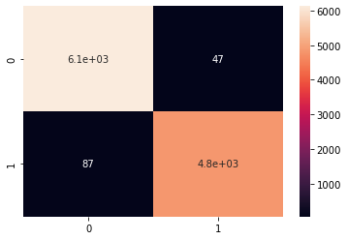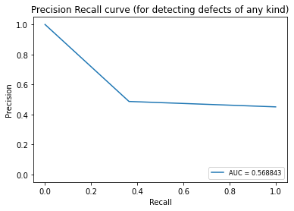

Error: 0.45754518705338376
the second test should value 0. clasified as [0]
the third test should value 0. clasified as [0]
the forth test should value 1. clasified as [1]
the fifth test should value 1. clasified as [1]
test Result: Accuracy Score: 54.04%
train Result: Accuracy Score: 98.79%
the main classes predicted class 0

Appendix D1 – SUS Survey Questions
- I think that I would like to use this system frequently.
- I found the system unnecessarily complex.
- I thought the system was easy to use.
- I think that I would need the support of a technical person to be able to use this system.
- I found the various functions in this system were well integrated.
- I thought there was too much inconsistency in this system.
- I would imagine that most people would learn to use this system very quickly.
- I found the system very cumbersome to use.
- I felt very confident using the system.
- I needed to learn a lot of things before I could get going with this system.
Appendix D2 – SUS Survey results
Tester | Q1 | Q2 | Q3 | Q4 | Q5 | Q6 | Q7 | Q8 | Q9 | Q10
1 | 3 | 2 | 4 | 1 | 4 | 2 | 5 | 1 | 4 | 1
2 | 4 | 3 | 4 | 1 | 4 | 2 | 5 | 2 | 3 | 1
3 | 2 | 1 | 5 | 1 | 4 | 1 | 4 | 1 | 4 | 2
4 | 3 | 1 | 5 | 1 | 5 | 1 | 5 | 1 | 5 | 1
5 | 3 | 2 | 4 | 2 | 4 | 2 | 4 | 2 | 4 | 1
6 | 3 | 1 | 5 | 1 | 5 | 1 | 5 | 1 | 5 | 1
7 | 3 | 1 | 5 | 2 | 3 | 1 | 5 | 1 | 4 | 3
8 | 1 | 2 | 3 | 1 | 3 | 4 | 4 | 3 | 3 | 3
9 | 4 | 1 | 5 | 2 | 4 | 2 | 4 | 1 | 4 | 3
10 | 3 | 1 | 5 | 1 | 4 | 2 | 5 | 1 | 5 | 1
11 | 4 | 1 | 5 | 1 | 4 | 5 | 5 | 1 | 5 | 1
12 | 3 | 1 | 4 | 1 | 4 | 1 | 5 | 1 | 4 | 2

Appendix E1 – UEQ Questions

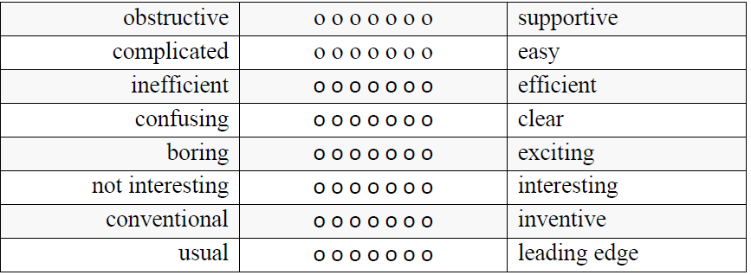
Figure A.1 UEQ questions (Schrepp, 2023)

Appendix E2 – UEQ Raw Results

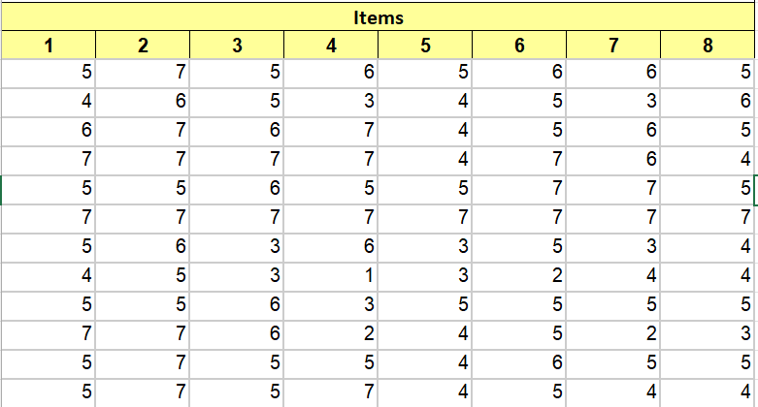

Appendix E3 – UEQ Averages for Each Tester
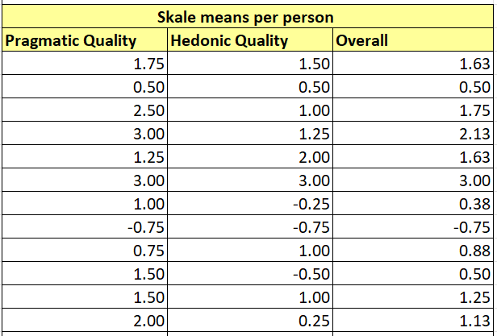

Appendix E4 – UEQ Confidence Intervals
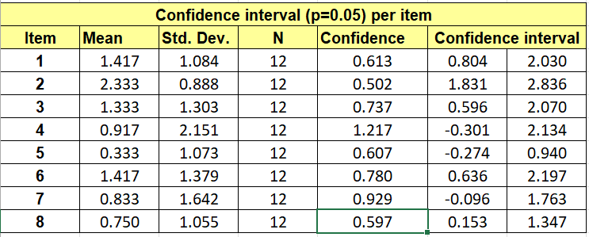
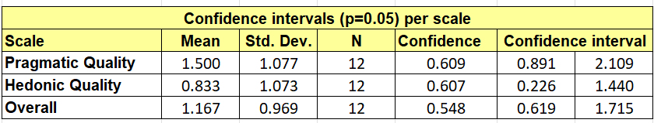

Appendix E5 – UEQ Scale Correlations
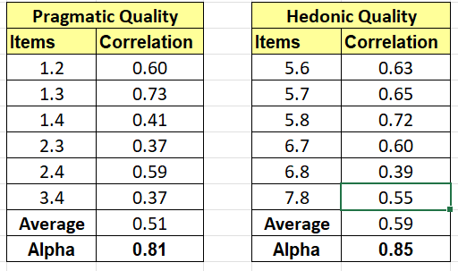

Appendix F – UEQ Cleaned Results
Appendix F1 – UEQ Cleaned Results Breakdown.

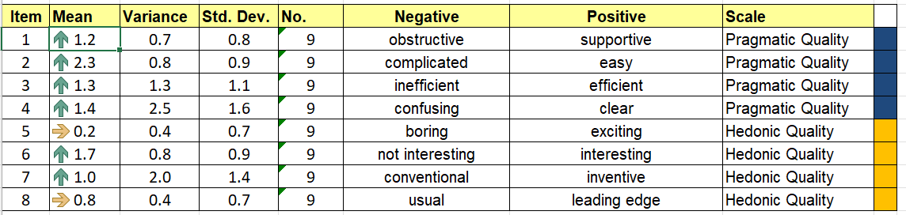

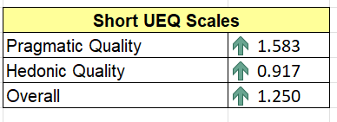

Appendix F2 – UEQ Cleaned Mean value graph.

Appendix F3 – UEQ Cleaned Results Negative Neutral Positive Graph.

Appendix F4 – UEQ Cleaned Confidence Intervals.

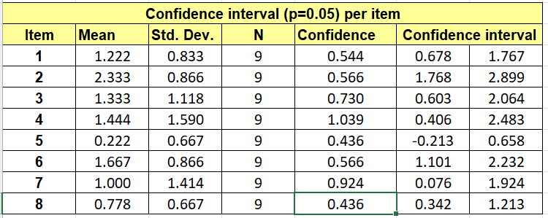
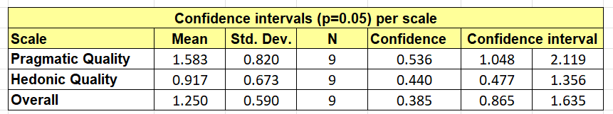

Appendix F5 – UEQ Cleaned Scale Correlations

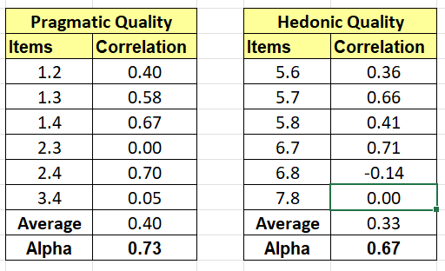

Appendix F6 – UEQ Cleaned Benchmark results

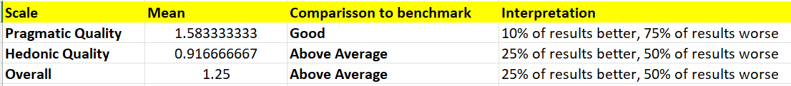

Appendix G – MLA Development Code

# Importing the libraries
from sklearn.metrics import confusion_matrix, zero_one_loss, roc_curve, auc
from sklearn.model_selection import train_test_split
from sklearn.metrics import accuracy_score, classification_report
from sklearn.multiclass import OneVsRestClassifier
from sklearn.metrics import precision_recall_curve
import matplotlib.pyplot as plt
import seaborn as sns # visualisation library
import pandas as pd
import numpy as np
import joblib

def print_score(features, target, clf, text):
# use the given model to predict on the given features
pred = clf.predict(features)

# produce a classification report using sklearn's methods
clf_report = pd.DataFrame(classification_report(target, pred, output_dict=True))

# display everything in a fomratted way
print(text, " Result:\n================================================")
print(f"Accuracy Score: {accuracy_score(target, pred) * 100:.2f}%")
print("_______________________________________________")

print(f"CLASSIFICATION REPORT:\n{clf_report}")
print("_______________________________________________")

cm = confusion_matrix(target, pred)
plt.figure()
sns.heatmap(cm, annot=True)

# can also write the cm as text
#print(f"Confusion Matrix: \n {cm}\n")

features_names = ['userId', 'emotionIndex', 'index', 'keyCode', 'keyDown', 'keyUp', 'D1U1', 'D1U2', 'D1D2', 'U1D2', 'U1U2', 'D1U3', 'D1D3', 'answer']
raw_data_filename = "TypingDatasetKeyCode.csv"
raw_data = pd.read_csv(raw_data_filename, header=None, delimiter=",", names=features_names)

#Exploratory Data Analysis
raw_data = raw_data.iloc[1:]
raw_data = raw_data.drop('index', axis=1)
raw_data = raw_data.drop('userId', axis=1)
#raw_data = raw_data.drop('keyCode', axis=1)
raw_data = raw_data.drop(raw_data[raw_data['answer'] == 'W'].index)
raw_data = raw_data.drop('answer', axis=1)
raw_data = raw_data.dropna()

raw_data['emotionIndex'] = raw_data['emotionIndex'].astype('int')
raw_data['keyCode'] = raw_data['keyCode'].astype('int')
raw_data['keyDown'] = raw_data['keyDown'].astype('int')
raw_data['keyUp'] = raw_data['keyUp'].astype('int')
raw_data['D1U1'] = raw_data['D1U1'].astype('int')
raw_data['D1D2'] = raw_data['D1D2'].astype('int')
raw_data['D1U2'] = raw_data['D1U2'].astype('int')
raw_data['U1D2'] = raw_data['U1D2'].astype('int')
raw_data['U1U2'] = raw_data['U1U2'].astype('int')
raw_data['D1U3'] = raw_data['D1U3'].astype('int')
raw_data['D1D3'] = raw_data['D1D3'].astype('int')

print (raw_data.head())
print (raw_data.shape)
print (raw_data.info())
print (raw_data.describe())
#print (raw_data.isnull())
#print (raw_data.isnull())
#no nulls

cols = ['keyCode','keyDown', 'keyUp', 'D1U1', 'D1U2', 'D1D2', 'U1D2', 'U1U2', 'D1U3', 'D1D3']
X = raw_data.loc[:, cols].values
y = raw_data.loc[:,'emotionIndex'].values
#print(y.head())

# N = 0 C = 1 H = 2 A = 3 S = 4

X_train, X_test, y_train, y_test = train_test_split(X,y, train_size=0.8, test_size=0.2, shuffle=True)
print ("X_train, y_train:", X_train.shape, y_train.shape)
print ("X_test, y_test:", X_test.shape, y_test.shape)

from sklearn.ensemble import RandomForestClassifier

#create Classifier object
classif= OneVsRestClassifier((RandomForestClassifier(n_estimators = 50, random_state = 1, bootstrap = True, max_features="log2", oob_score= True)))

# fit the Classifier with x and y data
classif.fit(X_train, y_train)
y_pred = classif.predict(X_test) # crisp predictions (0 or 1)
y_probs = classif.predict_proba(X_test) # probability predictions between [0, 1]
#y_score = classif.decision_function(X_test)

fpr = {}
tpr = {}
thresh ={}

n_class = 5

for i in range(n_class):
fpr[i], tpr[i], thresh[i] = roc_curve(y_test, y_probs[:,i], pos_label=i)
#fpr[i], tpr[i], thresh[i] = roc_curve(y_test, y_pred[:,i], pos_label=i)

# plotting
plt.plot(fpr[0], tpr[0], linestyle='--',color='orange', label='Class 0 vs Rest')
plt.plot(fpr[1], tpr[1], linestyle='--',color='green', label='Class 1 vs Rest')
plt.plot(fpr[2], tpr[2], linestyle='--',color='blue', label='Class 2 vs Rest')
plt.plot(fpr[3], tpr[3], linestyle='--',color='red', label='Class 3 vs Rest')
plt.plot(fpr[4], tpr[4], linestyle='--',color='black', label='Class 4 vs Rest')
plt.title('Multiclass ROC curve')
plt.xlabel('False Positive Rate')
plt.ylabel('True Positive rate')
plt.legend(loc='best')
plt.savefig('Multiclass ROC',dpi=300);
plt.plot

y_score = []
for n in range(len(y_test)):
label = y_test[n]
#y_score.append(sum(y_pred[n,:])) #sum probabilities of all attack categories excluding normal
y_score.append(np.argmax(y_probs[n,:])) #sum probabilities of all attack categories excluding normal
# should it be appended, why not use y_probs directly?

y_score = np.array(y_score)
precision, recall, thresholds_precision_recall = precision_recall_curve(y_test, y_score, pos_label=1)
auc_pr = auc(recall, precision)

print_score(X_test, y_test, classif, 'test')
print_score(X_train, y_train, classif, 'train')

print ("Computing performance metrics")
error = zero_one_loss(y_test, y_pred)
# By definition, entry i,j in a confusion matrix is the number of observations actually in group i, but predicted to be in group j
print ("Error: ", error)

plt.figure()
plt.plot(recall, precision, label='AUC = %0.6f' % (auc_pr))
plt.xlabel('Recall')
plt.ylabel('Precision')
plt.xlim([-0.05, 1.05])
plt.ylim([-0.05, 1.05])
plt.title('Precision Recall curve (for detecting defects of any kind)')
plt.legend(loc="lower right", prop={'size': 'small'})
plt.savefig('Precision Recall curve for RF.png')
plt.savefig('Precision Recall curve for RF.pdf')
plt.show()

testa = np.array([106, 1, 1, 96, 349, 211, 115, 253, 463, 379]).reshape(1, -1)#0
testb = np.array([105, 1, 1, 114, 337, 259, 145, 223, 657, 418]).reshape(1, -1)#2
testc = np.array([104, 1, 1, 71, 1594, 1487, 1416, 1523, 1838, 1694]).reshape(1, -1)#1
testd = np.array([32, 1, 1, 132, 687, 587, 455, 555, 882, 814]).reshape(1, -1)#3
teste = np.array([117, 1, 1, 74, 256, 153, 79, 182, 636, 542]).reshape(1, -1)#4

Test1 = classif.predict(testa)
Test2 = classif.predict(testb)
Test3 = classif.predict(testc)
Test4 = classif.predict(testd)
Test5 = classif.predict(teste)

print ("the first test should value 0. clasified as ", Test1)
print ("the second test should value 2. clasified as ", Test2)
print ("the third test should value 1. clasified as ", Test3)
print ("the forth test should value 3. clasified as ", Test4)
print ("the fifth test should value 4. clasified as ", Test5)

# save model with joblib
filename = 'RFModel.sav'
joblib.dump(classif, filename)

Appendix H – Support Tool Source Code

import sys
from PyQt6 import QtWidgets
from PyQt6.QtWidgets import QMessageBox
from PyQt6.QtGui import QPixmap
from testUI import Ui_MainWindow
from pynput import keyboard
import pandas as pd
import joblib
import numpy as np
import time
import random
import threading

#mutex lock
lock=threading.Lock()

# load model with joblib
filename = 'RFModel.sav'
classif = joblib.load(filename)

#load dictionary to hold advice
advice = {0: {1: 'You are doing fine keep going' , 2: 'Your mind is clear ready to work' , 3:'You have a clear mind dont get distracted' },
1 : {1:'Keep calm and carry on', 2:'You make your best disisions when you are calm' , 3: 'You are the sky. Everything else is just the weather'},
2 : {1:'Keep up the Positive mental attatude', 2:'Your happiness brightens up the world around you' , 3: 'Happiness is a choice. So keep choosing right'},
3 : {1:'exhale slowly, releasing all the air from your lungs. Count to 4 and inhale through your nose. Hold a deep breath for 4 seconds, then exhale for another count of 4. Repeat several times', 2:'Anger is temporary. take a step back and it will pass' , 3: 'Holding a grudge is like drinking poison and waiting for the other person to die'},
4 : {1:'Life has its highs and lows. Without the lows the highs wouldn,t be quite so high. So keep going', 2:'Go for a walk out in the sun it can realy help ' , 3: 'Everything will be OK in the end, if it is not OK, it is not the end.'}}

def on_press(key): #function for keybord listener
try:
hold.kdtemp = int(round(time.time() * 1000))
print(hold.kdtemp)
hold.keycode = key.char
except AttributeError:
print('special key {0} pressed'.format(key))
hold.check = 1

def on_release(key): #function for keybord listener
if(hold.check != 1):
hold.kutemp = int(round(time.time() * 1000))
print(hold.kutemp)
print(hold.keycode)
lock.acquire()
UpdateKeyData(hold.kutemp, hold.kdtemp)
lock.release()
else:
hold.check=0

def UpdateKeyData(keyUp, keyDown): #function for updating keyboard data
hold.kd1 = hold.kd2
hold.ku1 = hold.ku2
hold.kd2 = hold.kd3
hold.ku2 = hold.ku3
hold.kd3 = keyDown
hold.ku3 = keyUp
print(hold.kd1, hold.ku1, hold.kd2, hold.ku2, hold.kd3, hold.ku3, hold.keycode)

def CalculateImput():
hold.D1U1 = hold.ku1 - hold.kd1
hold.D1U2 = hold.ku2 - hold.kd1
hold.D1D2 = hold.kd2 - hold.kd1
hold.U1D2 = hold.kd2 - hold.ku1
hold.U1U2 = hold.ku2 - hold.ku1
hold.D1U3 = hold.ku3 - hold.kd1
hold.D1D3 = hold.kd3 - hold.kd1
print(hold.D1U1, hold.D1U2, hold.D1D2, hold.U1D2, hold.U1U2, hold.D1U3, hold.D1D3)

class Variables:
showimg = 1
kd1 = 0
ku1 = 0
kd2 = 0
ku2 = 0
kd3 = 0
ku3 = 0
kutemp = 0
kdtemp = 0
keycode = ' '
D1U1 = 0
D1U2 = 0
D1D2 = 0
U1D2 = 0
U1U2 = 0
D1U3 = 0
D1D3 = 0
check = 0

class MainWindow(QtWidgets.QMainWindow, Ui_MainWindow):
def __init__(self, *args, obj=None, **kwargs): # loads the GUI for the application
super(MainWindow, self).__init__()
self.ui = Ui_MainWindow()
self.ui.setupUi(self)
self.ui.EstimateButton.clicked.connect(self.displayResult)
self.ui.ClearText.clicked.connect(self.ClearInput)
self.ui.newindow.clicked.connect(self.TestImage)

def TestImage (self, checked): #function for view image button
self.dialog = QtWidgets.QDialog()
self.dialog.setGeometry(15, 15, 300, 300)
lay = QtWidgets.QVBoxLayout(self.dialog)
label = QtWidgets.QLabel()
lay.addWidget(label)
pixmap = QPixmap( str(hold.showimg) + ".jpg")
hold.showimg = hold.showimg + 1
label.setPixmap(pixmap)
self.dialog.show()

if hold.showimg==6: # resets counter used to display images
hold.showimg = 1

def displayResult(self, s): # function for estimate mood button
lock.acquire()
CalculateImput()
keycode = ord( hold.keycode)
lock.release()
# predict result
testa = np.array([keycode, 1, 1, hold.D1U1, hold.D1U2, hold.D1D2, hold.U1D2, hold.U1U2, hold.D1U3, hold.D1D3]).reshape(1, -1)#0
Test1 = classif.predict(testa)

a = str(Test1)
a = int(a[1])
# N = 0 C = 1 H = 2 A = 3 S = 4
if a == 0:
feeling = 'Neutral'
elif a == 1:
feeling = 'Calm'
elif a == 2:
feeling = 'Happy'
elif a ==3:
feeling = 'Angry'
else:
feeling = 'Sad'

r = random.randrange(1,4)
dlg = QMessageBox(self)
dlg.setWindowTitle("Your Mood is")
dlg.setText("right now you are feeling " + feeling)
dlg.setInformativeText(advice[a][r])
dlg.exec()

def ClearInput (self, s): # function for clear text button
self.ui.TextImputbox.clear()

app = QtWidgets.QApplication(sys.argv)
listener = keyboard.Listener( #used for monitoring the keyboard
on_press=on_press,
on_release=on_release)
listener.start()
hold = Variables()
window = MainWindow()
window.show()
app.exec()

Appendix I – Data Management Sign Off

For undergraduate or postgraduate student projects supervised by an Abertay staff member.
This form MUST be included in the student’s thesis/dissertation. Note that failure to do this will mean that the student’s project cannot be assessed/examined.
Part 1: Supervisors to Complete
By signing this form, you are confirming that you have checked and verified your student’s data according to the criteria stated below (e.g., raw data, completed questionnaires, superlab/Eprime output, transcriptions etc.)

Student Name: | Connor Murphy
Student Number: | 1903299
Lead Supervisor Name: | Salma ElSayed
Lead Supervisor Signature | Salma ElSayed
Project title: | An evaluation of Machine Learning as a Mental Health Support tool
Study route: | PhD | MbR | MPhil
Study route: | Undergraduate | PhD by Publication
Part 2: Student to Complete
 |  | Initial here to confirm ‘Yes’
I confirm that I have handed over all manual records from my research project (e.g., consent forms, transcripts) to my supervisor for archiving/storage |  | CM
I confirm that I have handed over all digital records from my research project (e.g., recordings, data files) to my supervisor for archiving/storage |  | CM
I confirm that I no longer hold any digital records from my research project on any device other than the university network and the only data that I may retain is a copy of an anonymised data file(s) from my research |  | CM
I understand that, for undergraduate projects, my supervisor may delete manual/digital records of data if there is no foreseeable use for that data (with the exception of consent forms, which should be retained for 10 years) |  | CM
Student signature: | CMurphy
Date: | 17/04/2024

